Big 3 Warm Up for Thursday 01/04/18

## Word of the Day: VIGILANT

Definition(s):

Watchful; extremely alert

Example Sentence:

"The man is vigilant about eating foods which will not raise his cholesterol level."

Use the word of the day in a sentence and underline the word.

**Government Trivia:**

What was the first U.S. National Monument?   
a. Statue of Liberty   
b. Grand Canyon   
c. Devils Tower

**American History Trivia**

Between 1750 and 1900, which of the following industrializing states created an empire?

(A) Japan

(B) China

(C) Brazil

(D) Argentina

**Picture Response:**

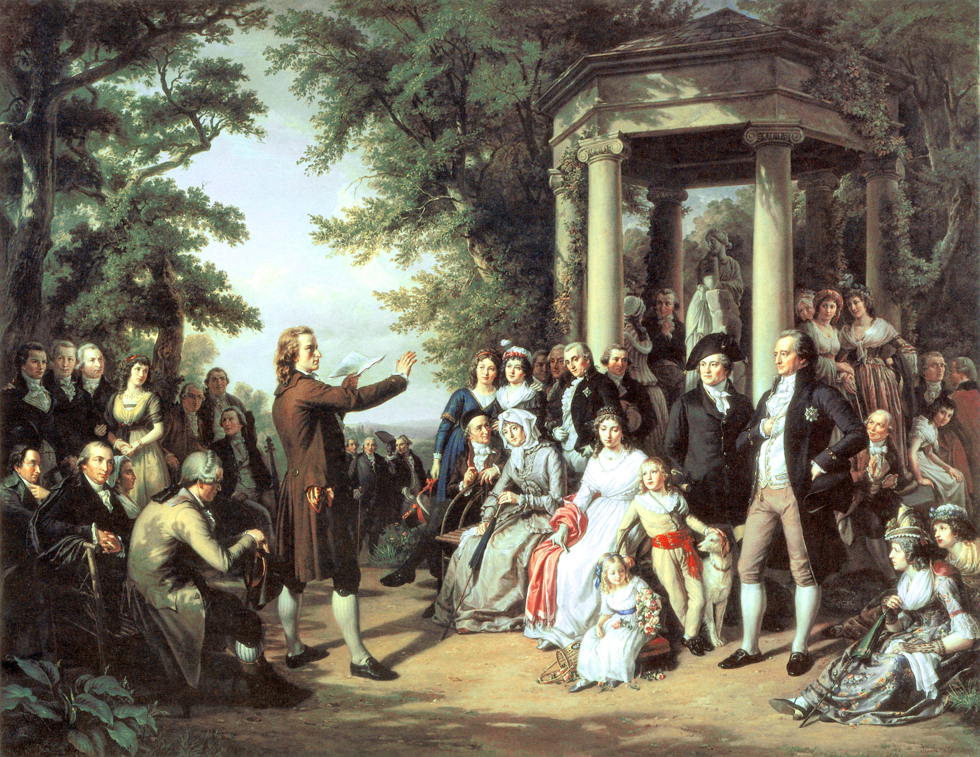

**Write a two to three sentence interpretation of this painting**

**Quote of the Week:**

“Preparation and the willingness to critically think when reviewing and studying for an upcoming exam is the key to success.”

- Mr. Kay

**A:** c. Devils Tower

**A: A. Japan**