Big 3 Warm Up 02/07

Word of the Day:

Verbatim • adverb and adjective
adverb: using exactly the same words
adjective: in precisely the same words used by a writer or speak

Use the word of the day in a sentence and underline the word.

8th Grade Social Studies Trivia:
What state were both Crazy Horse and Sitting Bull born in?

Picture Response:

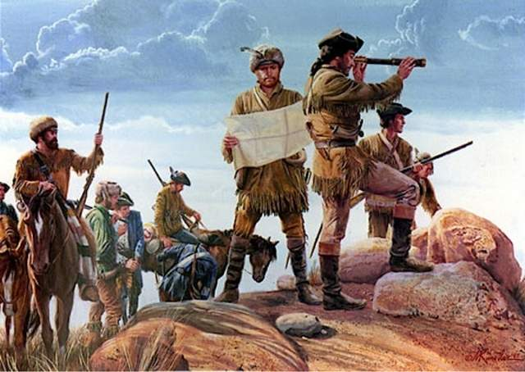

A: South Dakota
Quote of the Day:
“Actions speak louder than words.”

FDR

