**Big 3 Warm Up for Thursday 12/08**

## Word of the Day:

**ASSENT**

Definition(s):

To agree to

Example Sentence:

A treaty signed by the President is not valid until the Senate assents to its prescribed terms

Use the word of the day in a sentence and underline the word.

**Government Trivia:**

How many amendments were added to the Constitution in the twentieth century and or since 1912?

**World History Trivia**

Which of the following was an important virtue in

Confucianism?

(A) Warlike prowess

(B) Filial piety

(C) Public charity

(D) Poverty

(E) Manual labor

**Picture Response:**

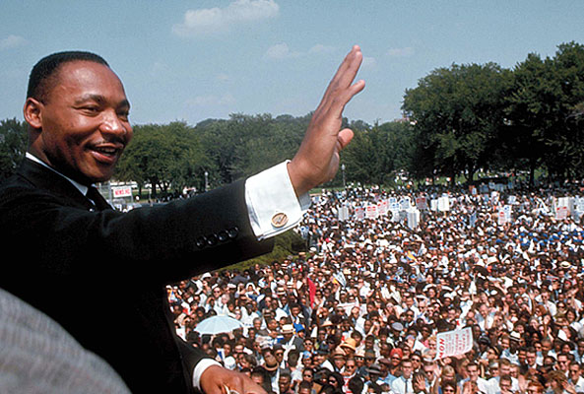

**Write a two to three sentence interpretation of this painting**

**Quote of the Day:**

“It is not the recognition that you may receive that matters, it’s the results that count.”

- Mr. Kay

**A: 12** The following amendments were added to the Constitution in the twentieth century:

* XVI: Establishment of an income tax (1913)
* XVII: Direct election of Senators (1913)
* XVIII: Prohibition (1919)
* XIX: Women's right to vote (1920)
* XX: Defines presidential and congressional terms and presidential succession (1933)
* XXI: Repeal of Prohibition (1933)
* XXII: Presidential term limit (1951)
* XXIII: District of Columbia residents right to vote (1961)
* XXIV: Abolishes poll taxes (1964)
* XXV: Presidential incapacitation; vice-presidential vacancy (1967)
* XXVI: Voting age lowered to 18 (1971)
* XXVII: Prohibits midterm pay raises for Congress (1992)

**A: Choice (B) is correct. According to The Analects, the**

**foundational text of Confucianism, filial piety (xiao) is**

**considered to be one of the key qualities that all humans**

**should seek to cultivate. As described by Confucius, filial**

**piety entails being obedient and caring toward one’s parents**

**and elder siblings, supporting them in their old age and**

**performing prescribed rituals for their spirits after their**

**death. Confucius argued that the universal practice of filial**

**piety is one of the requirements for the establishment of a**

**harmonious society.**