Big 3 Warm Up for 12/07

Word of the Day:
Balk, verb:

Definition(s):
1. to stop, as at an obstacle, and refuse to proceed or to do something specified
2. (of a horse, mule, etc.) to stop short and stubbornly refuse to go on.
3. to place an obstacle in the way of; hinder; thwart:

Example Sentence:
Now I was apprenticed to the best editor on an intellectual fashion magazine, and what did I do but balk and balk like a dull cart horse?

Use the word of the day in a sentence and underline the word.

8th Grade Social Studies Trivia:

What nation bid adieu to the United Kingdom in 1921?

What was the first company in the world to post $1 billion in annual earnings, in 1995?

Picture Response:

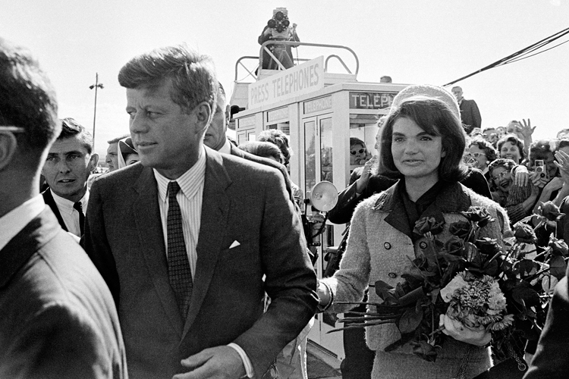

Write a two to three sentence interpretation of this painting

Quote of the Day:
“I am a success today because I had a friend who believed in me and I didn't have the heart to let him down...”
- Abraham Lincoln

A: Ireland
A: General Motors

