**Big 3 Warm Up for 12/05**

## Word of the Day:

**Misrepresent (verb)**

Definition(s):

To present in an inaccurate, false, or unfair fashion.

Example Sentence:

The senatorial candidate accused her opponent of misrepresenting her position on several important issues.

Use the word of the day in a sentence and underline the word.

**8th Grade Social Studies Trivia:**

### 1.  Who was the oldest delegate at age 81 at the Constitutional Convention and had to be helped to sign his name.

**Picture Response:**

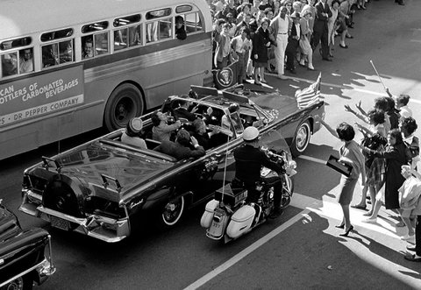

**Write a two to three sentence interpretation of this painting**

**Quote of the Day:**

[“I am a success today because I had a friend who believed in me and I didn't have the heart to let him down...”](http://www.quotesdaddy.com/quote/288/abraham-lincoln/i-am-a-success-today-because-i-had-a-friend-who-believed)

- Abraham Lincoln

**A: Franklin**

**A:**  Richard Nixon

A: Tax evasion. Convicted of income tax evasion in 1931 and sentenced to 11 years in prison, he was released on parole in 1939.