**Big 3 Warm Up for 12/03**

## Word of the Day:

**snafu** \sna-FOO, SNAF-oo\ , *noun*:

Definition(s):

A badly confused or ridiculously muddled situation

Example Sentence:

A ballot snafu in the election led to a recount.

Use the word of the day in a sentence and underline the word.

**8th Grade Social Studies Trivia:**

### What increased in the U.S. from 1.5 million to seven million in 1930?

### What city had the first public school, college and newspaper in the thirteen British colonies?

**Picture Response:**

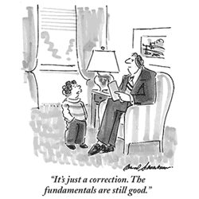

**Write a two to three sentence interpretation of this painting**

**Quote of the Day:**

[“I am a success today because I had a friend who believed in me and I didn't have the heart to let him down...”](http://www.quotesdaddy.com/quote/288/abraham-lincoln/i-am-a-success-today-because-i-had-a-friend-who-believed)

- Abraham Lincoln

**A:**  Unemployment

**A:** Boston