**Big 3 Warm Up for Wednesday 12/07**

## Word of the Day:

Balk, *verb*:

Definition(s):

**1.**  to stop, as at an obstacle, and refuse to proceed or to do something specified   
**2.** (of a horse, mule, etc.) to stop short and stubbornly refuse to go on.  
**3.**  to place an obstacle in the way of; hinder; thwart:

Example Sentence:

Now I was apprenticed to the best editor on an intellectual fashion magazine, and what did I do but **balk** and **balk** like a dull cart horse?

Use the word of the day in a sentence and underline the word.

**World History/Government Trivia:**

### What nation bid adieu to the United Kingdom in 1921?

### What was the first company in the world to post $1 billion in annual earnings, in 1995?

**Picture Response:**

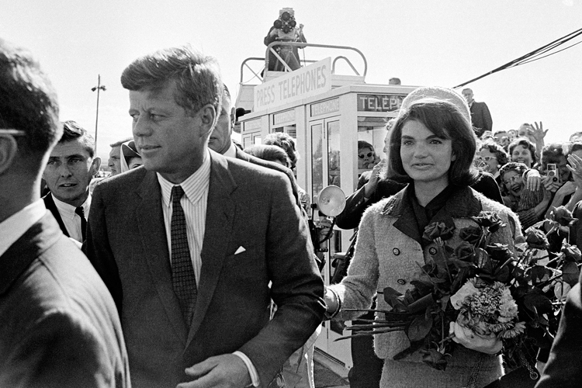

**Write a two to three sentence interpretation of this painting**

**Quote of the Day:**

[“I am a success today because I had a friend who believed in me and I didn't have the heart to let him down...”](http://www.quotesdaddy.com/quote/288/abraham-lincoln/i-am-a-success-today-because-i-had-a-friend-who-believed)

- Abraham Lincoln

**A:**  Ireland

**A:** General Motors