Big 3 Warm Up 02/28/19

Word of the Day: Evenfall

Noun

Definition: The beginning of evening; twilight; dusk.

Example Sentence: When he came home at evenfall he often showed his brothers and sisters the tips he earned from working as a waiter at the restaurant downtown.

8th Grade Social Studies Trivia:

How much money did James Monroe pay to purchase Florida from Spain?

Picture Response

Write a two to three sentence interpretation of the image.

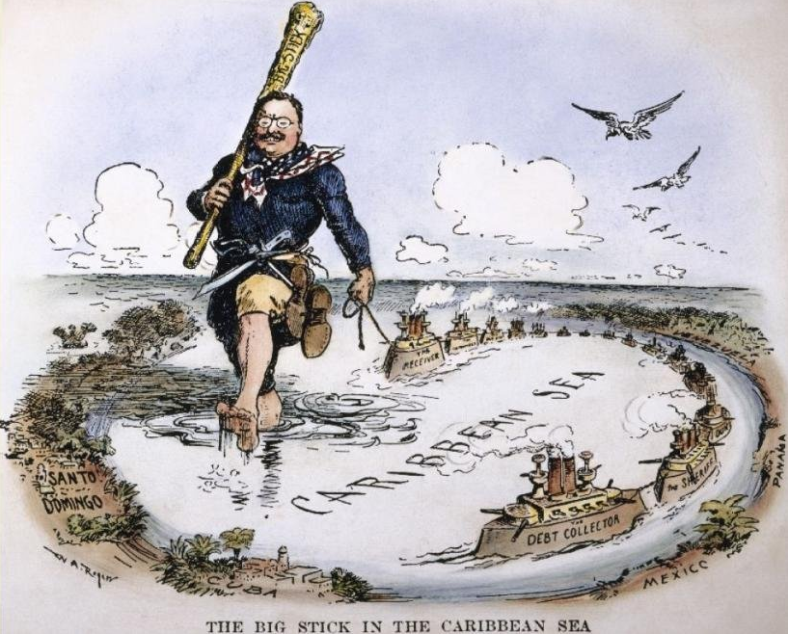

Quote of the Day
Those who do not remember the past are condemned to repeat it.

Monroe was able to buy Florida for $5 million. Monroe had started talks with Spain about Florida while he was James Madison’s secretary of state in 1815. After violence in the region and a flurry of diplomacy, Adams helped negotiate a deal for Monroe where the U.S. would pay off damage claims made by Spain during the violence.

