Big 3 Warm Up 02/26

Word of the Day: Inane

- : empty, insubstantial
- : lacking significance, meaning, or point

Example Sentence: The surfeit of home runs is a sop to all the Philistines who require inane diversions like programmed races between electronic dots on the scoreboard to make it through a two-hit shutout.

8th Grade Social Studies Trivia:

Which five states were admitted to the union during Monroe’s presidency?

Picture Response
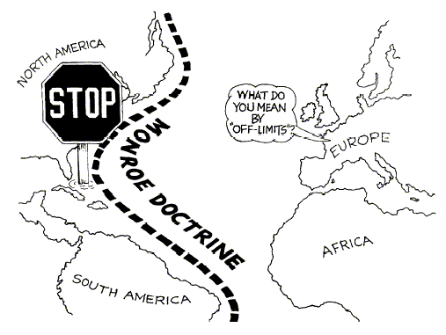

Write a two to three sentence interpretation of the historic painting.

Illinois, Alabama, Maine, Missouri and Mississippi

