Big 3 Warm Up 02/25

Word of the Day: Reprieve

Verb

- to prevent (something) from being closed, destroyed, etc., for a period of time

Example Sentence: The library has been reprieved and will remain open for at least another year.

8th Grade Social Studies Trivia

The capital of what country, named Monrovia, was named after James Monroe? It is the only non-U.S. capital city to be named after a U.S. president.

Picture Response

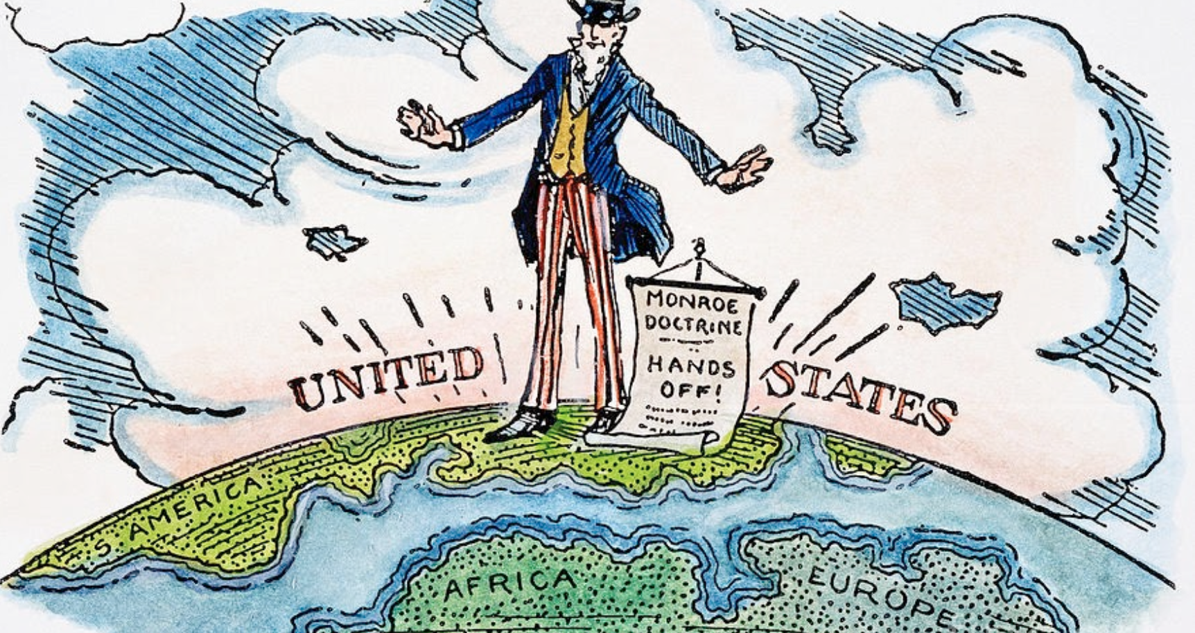
Write two to three sentences based off the picture/painting

Quote of the Day
Never in the field of human conflict was so much owed by so many to so few.

Liberia

