Big 3 Warm Up 2/14

Word of the Day:

Facilitation

Definition: act of assisting or making easier the progress or improvement of something

Example: If you volunteer to help with the facilitation of enrolling new students at a school, you might be by the door, handing out forms and directing families to the main office.

Please write a sentence using the word of the day. Underline the word of the day in your sentence.

8th Grade Social Studies Trivia:

Who appeared on the $5000 Bill before the government stopped printing these in 1945?

Picture Response:

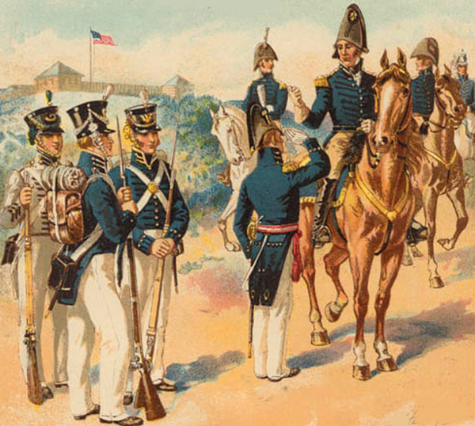

Your response to the above painting must be at least two sentences in length

James Madison

