Big 3 Warm Up 02/12

Word of the Day:

Accolade • noun

Definition: An expression of praise or admiration. An award or privilege granted; an acknowledgment of merit.

Example Sentence: The scientist was given many accolades for his research

Use the word of the day in a sentence and underline the word.

8th Grade Social Studies Trivia:

Before this U.S. president, no left-handed American president had ever served two terms. Who is this president?

Picture Response:
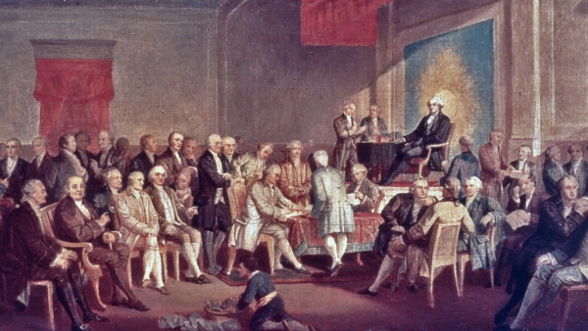

Quote of the Day:
“Actions speak louder than words.”

William Clinton

