Big 3 Warm Up 02/11

Word of the Day:

Collaboration

Definition: act of working jointly

EXAMPLE SENTENCE:
But if you look at the institutions involved in this massive undertaking it’s clearly an international collaboration.

Please write a sentence using the word of the day. Underline the word of the day in your sentence.

8th Grade Social Studies Trivia:

What U.S. President was born with the name Leslie Lynch King, Jr.?

Picture Response:

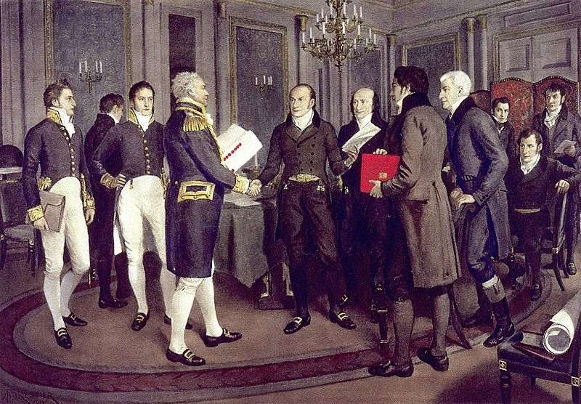

Gerald Ford

