Big 3 Warm Up 02/08

Word of the Day:

Perceptive • adjective
1. of or relating to perception
2. having the ability to perceive or understand; keen in discernment

Use the word of the day in a sentence and underline the word.

8th Grade Social Studies Trivia:

This U.S. President was the only man who held both the Presidency and the Vice-Presidency but who was not elected to either post. Who was this U.S. President?

Picture Response:

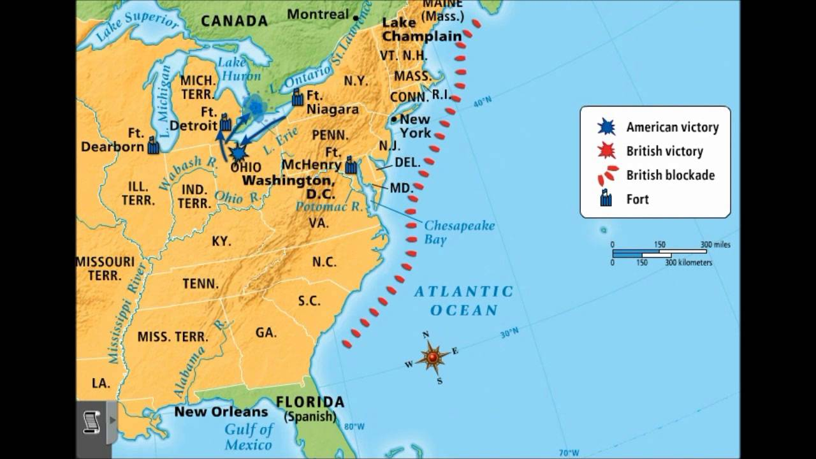

Quote of the Day:
“Actions speak louder than words.”

Gerald Ford

