Big 3 Warm Up 02/05

Word of the Day:

Scenario • noun

1. An outline or synopsis of a play (or, by extension, of a literary work)
2. A setting for a work of art or literature
3. A postulated sequence of possible events

8th Grade Social Studies Trivia:

When did the Lewis and Clark Expedition Begin?

Picture Response:
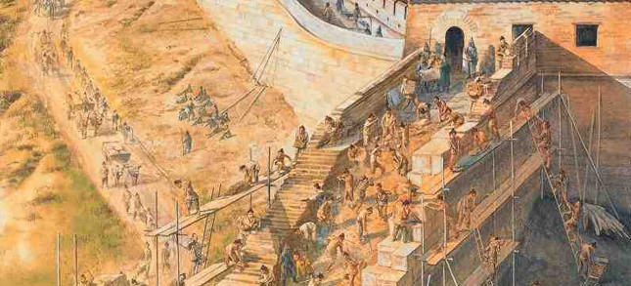

May 1804.

