Big 3 Warm Up 12/03

Word of the Day: TREPIDATION

Definition:
1. A fearful state; a state of hesitation or concern.
2. An involuntary trembling, sometimes an effect of paralysis, but usually caused by terror or fear; quaking; quivering.

Example Sentence: I took on the role with considerable trepidation for a variety of reasons.

Use the word of the day in a sentence that you have created and underline the word.

World History/Government Trivia:
Who was the first American President to win the Nobel Peace Prize?

Picture Response: Write a two to three sentence interpretation of this historic painting

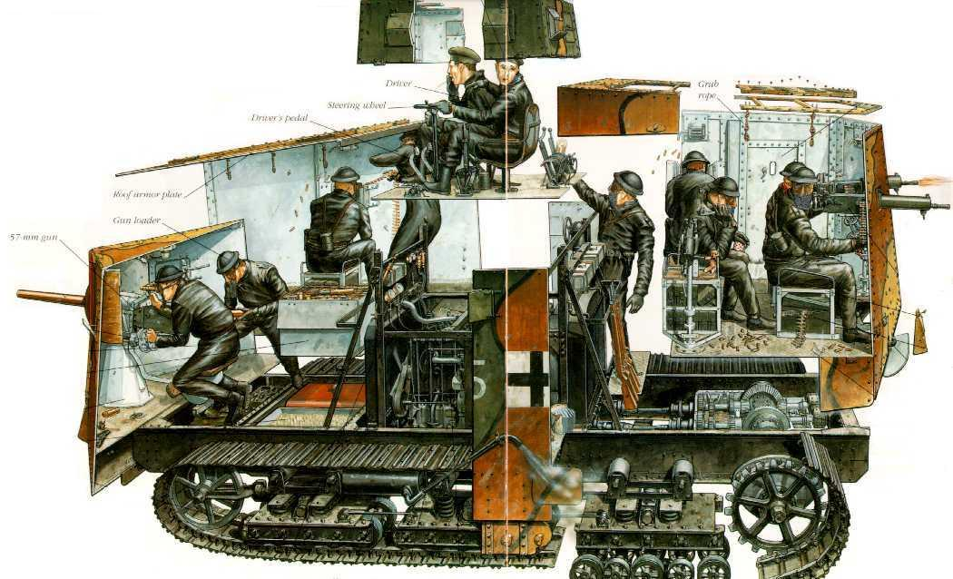

Quote of the Day: “One must always maintain one's connection to the past and yet ceaselessly pull away from it.”
Gaston Bachelard

Answer Trivia : Theodore Roosevelt

