Big 3 Warm Up 4/27

Word of the Day:
irony •\ noun
1. incongruity between what might be expected and what actually occurs
2. a trope that involves incongruity between what is expected and what occurs
3. witty language used to convey insults or scorn
Example Sentence: We see a couple of codgers, oblivious to the musical revolution happening in front of them, complaining that Kool Herc is cutting between records too quickly. This may be intended as irony, but it mostly lets audiences congratulate themselves for their superior knowledge.

World History/Government Trivia:

- Who expected to be paid 2,000 pounds for surrendering West Point to the British?

- Whose migraine headache vanished after he read Robert E. Lee's note of surrender?

Picture Response:
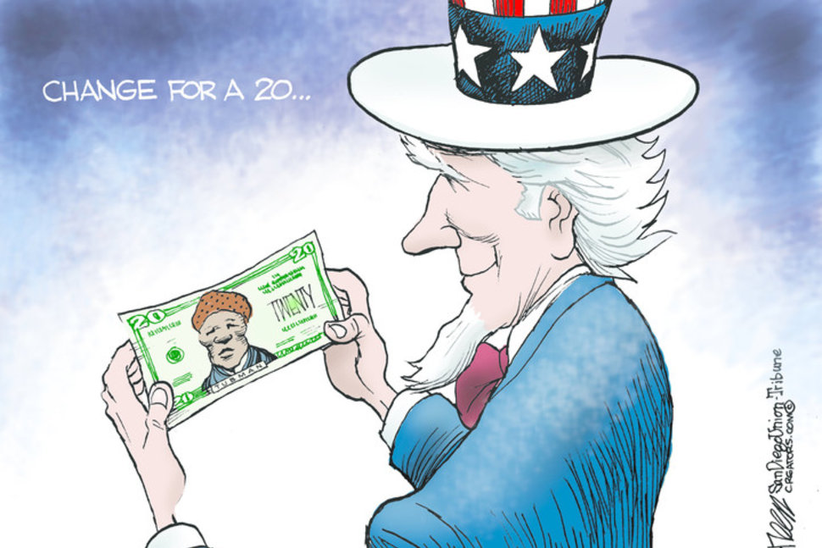

A: Benedict Arnold.
http://www.triviaplaying.com/72_history_Q_.htm

