Big 3 Warm Up 4/24

Word of the Day:
equinox • noun
1. either of two times of the year when the sun crosses the plane of the earth’s equator and day and night are of equal length
2. (astronomy) either of the two celestial points at which the celestial equator intersects the ecliptic
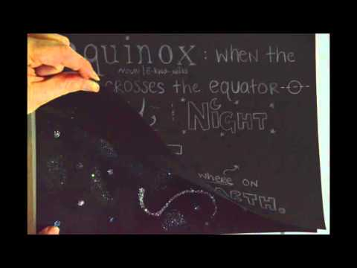

8th Grade Social Studies Trivia:

What fruit or vegetable did the pioneers ate a lot of on the Oregon Trail?

Picture Response:

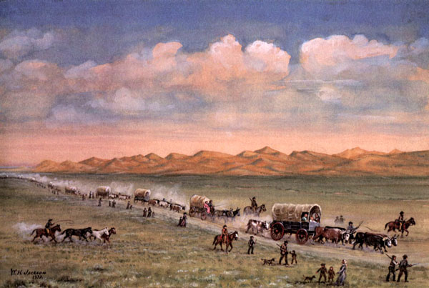

Although the pioneers didn't know the scientific reason for it, they knew that eating fresh fruits and vegetables would keep them safe from the deficiency disease, scurvy. Because fresh fruits and vegetables were hard to come by over much of the trail, pioneers would bring a lot of pickles along, which also were an excellent source of Vitamin C.

