Big 3 Warm Up 4/20

Word of the Day:

junket • noun and verb
noun: a trip taken by an official at public expense
noun: a dessert made of sweetened milk coagulated with rennet
verb: go on a pleasure trip
verb: provide a feast or banquet for
verb: partake in a feast or banquet
Example Sentence: It is a junket, an affair lavishly catered at the Kremlin’s expense, at which Mr. Putin puts forward his vision of himself and his country.

World History/Government Trivia:

When was Pearl Harbor attacked by the Japanese Air Force?
a) September 3, 1939
b) December 7, 1941
c) June 22, 1942
d) May 7, 1945

Picture Response:

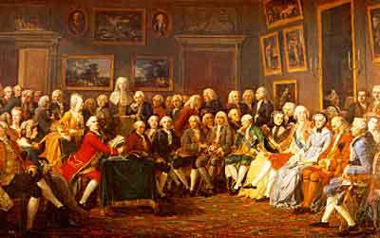

Quote of the day: “The strength to have the will and determination to prove those who believe that you are going to fail, may possibly be the strongest motivational tool one may desire.” Mr. Kay

Answer to Trivia: B

