Big 3 Warm Up 4/28/14

Word of the Day:
Vim, noun:

Definition: Power; force; energy; spirit; activity; vigor.

Example Sentence: The 76-year-old retired Malaysian schoolteacher displayed so much vim during a recent hike through a national park in Sarawak, astonished rangers began calling her a "recycled teenager."

Use the word of the day in a sentence and underline the word.

World History/Government Trivia:

The only non-Presidents to adorn US currency are: $1 coin, (blank); $10 bill, Alexander Hamilton; $100 bill, Benjamin Franklin; $10,000 bill, Salmon P. Chase. Who is on the $1 U.S. coin?

Picture Response:
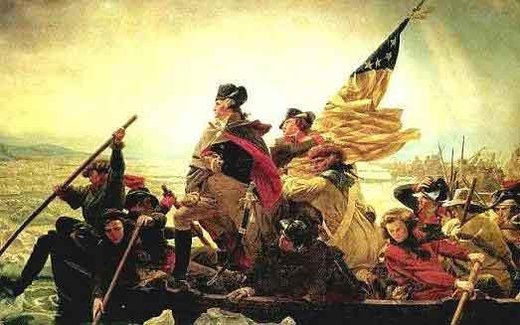

Write a two to three sentence interpretation of this historic painting

Susan B. Anthony
Quote of the Day:
“Actions speak louder than words.”

