**Big 3 Warm Up 2/7/13 Thursday**

**Word of the Day:**

[**Collaboration**](http://www.vocabulary.com/dictionary/collaboration)

Definition: act of working jointly

EXAMPLE SENTENCE:

But if you look at the institutions involved in this massive undertaking it’s clearly an international **collaboration**.

Please write a sentence using the word of the day. Underline the word of the day in your sentence.

**Government Trivia:**

What U.S. President was born with the name Leslie Lynch King, Jr.?

**Picture Response (Government):**

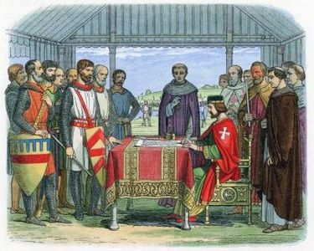

**Picture Response (In honor of Black History Month):**

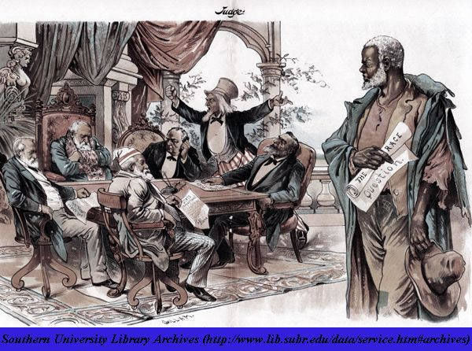

Gerald Ford