**Big 3 Warm Up 2/1**

**Word of the Day:**

**scenario • noun**

1. An outline or synopsis of a play (or, by extension, of a literary work)

2. A setting for a work of art or literature

3. A postulated sequence of possible events

**Government Trivia:**

The Constitutional Convention met in what U.S. city?

**Picture Response:**

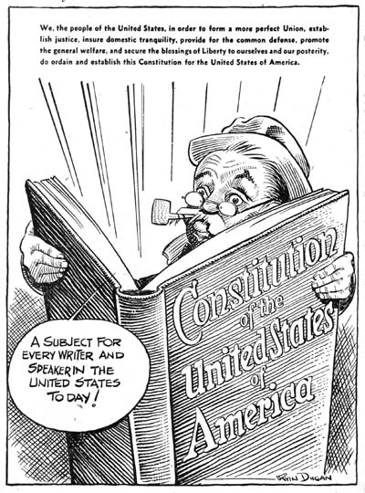

Write a two to three sentence response