Big 3 Warm Up 2/13/13

Word of the Day:

Irreverent (adj)

Definition: Lacking proper respect.

The child was wholly irreverent: she stuck out her tongue at the minister and yelled names at her grandparents.

Use the word of the day in a sentence and underline the word.

History/Government Trivia:
Antonia ('Tonie') Nathan, the 1972 Vice-Presidential candidate of the (blank) Party, was the first woman in American history to receive an electoral vote. Which political party did she belong to?

Picture Response:

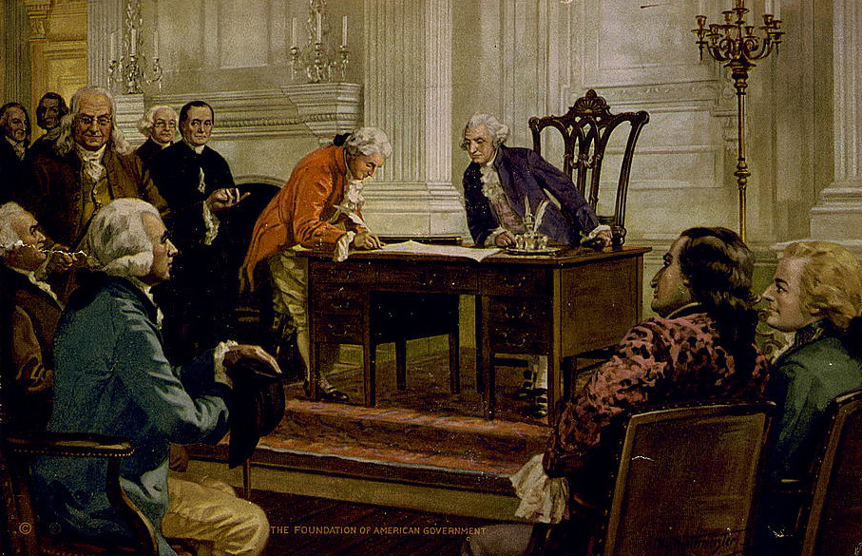

Write a two to three sentence interpretation of this historic painting

Quote of the Day:
“Actions speak louder than words.”

Libertarian Party

