**Big 3 Warm Up 1/28**

**Word of the Day:**

### Plagiarize • verb

Definition: Take without referencing from someone else’s writing or speech; of intellectual property

Use the word of the day in a sentence and underline the word.

**Government Trivia:**

Take the case of (blank), a U.S. congressman in the nineteenth century. This person wanted more than anything else to be President of the United States. He was offered the vice-presidency by William Henry Harrison, but turned it down. Then Harrison died in office. Again this person was offered the vice-presidency, by Zachary Taylor, but declined. Taylor died in office. This person never did become President, who is he?

**Picture Response:**

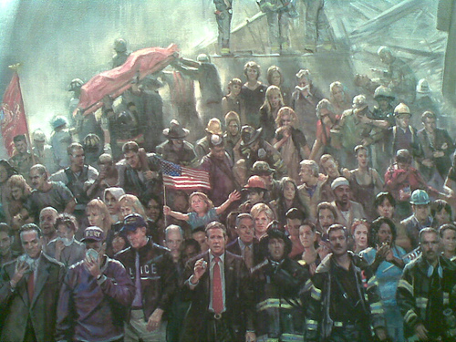

**Write a two to three sentence response**

**Quote of the Day:**

**“Actions speak louder than words.”**

Daniel Webster