**Big 3 Warm Up 1/27**

**Word of the Day:**

### Discretion •noun

**1.** the power of making free choices unconstrained by external agencies  
**2.** freedom to act or judge on one’s own  
**3.** the trait of judging wisely and objectively  
**4.** knowing how to avoid embarrassment or distress  
**5.** refined taste; tact

Underline the word of the day and use it in a sentence that you have created.

**World History/American Government Trivia:**

This President was the first American President to win the Nobel Peace Prize. He won for his arbitration of treaty discussions at the end of the Russo-Japanese War.

Who am I referring to?

**Picture Response:**

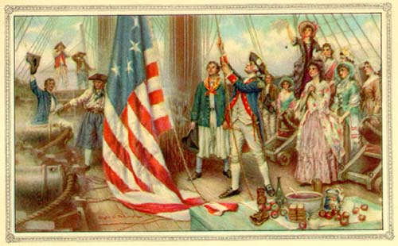

**(Example of student response)**

Responses will vary

**Quote of the School Year:**

**“Actions speak louder than words.”**

Theodore Roosevelt