Big 3 Warm Up 10/16

Word of the Day:
Narcissism, noun:

Definition: excessive love or admiration for oneself; in psychoanalysis, gratification manifested in admiration and love of oneself

Example Sentence: They found that the number of "Friends" on a person's Facebook and the number of "wall posts" they have there correlated with their narcissism.

Use the word of the day in a sentence and underline the word.

History/Government Trivia:

Which of the states uses the Napoleonic code rather than English common law as the basis for its civil law?

Picture Response:
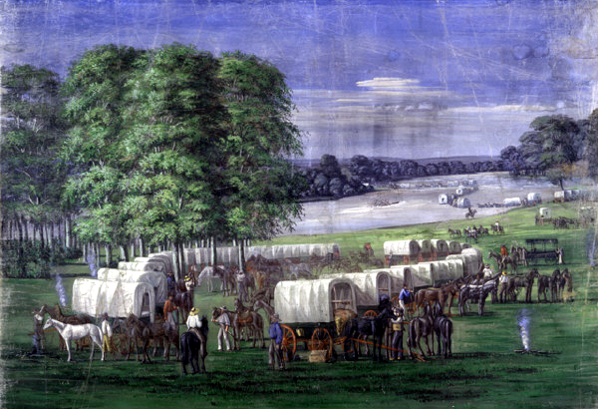

Write a two to three sentence interpretation of this historic painting

Louisiana

Quote of the Day:
“Actions speak louder than words.”

