Big 3 Warm Up 05/21/13

Word of the Day:
Misprize, transitive verb:

Definition:
1. To hold in contempt.
2. To undervalue.

Example Sentence: I hesitate to appear to misprize my native city, but how can the history of dear, sedate old London town possibly compare to Paris for sheer excitement?

Use the word of the day in a sentence and underline the word.

Government Trivia:

Which American colony was the first to enact anti-slavery legislation?

Picture Response:

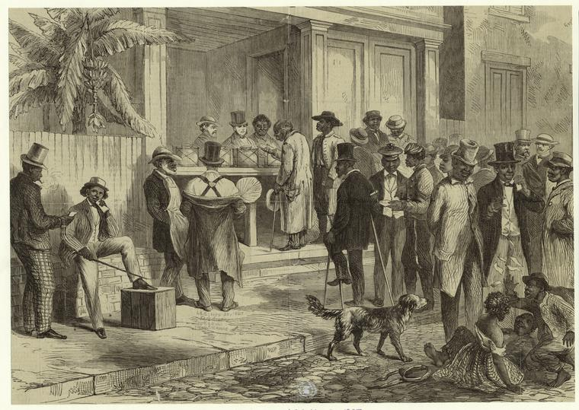

Write a two to three sentence interpretation of this historic painting

Massachusetts, in 1641, in its "Body of Liberties."

Quote of the Day:
“Actions speak louder than words.”

