Big 3 Warm Up 05/01

Word of the Day:

Collateral (noun)

Definition: Money or resources offered in exchange for a loan.

Example Sentence: At the bank, the farmer put forth his herd of cows as collateral for a loan that would enable him to update his barn.

Use the word of the day in a sentence and underline the word.

World History/Government Trivia:
All three major (blank) Presidential candidates, Clinton, Dole and Perot, were left-handed. What year did all three of them run for the presidency?

Picture Response:

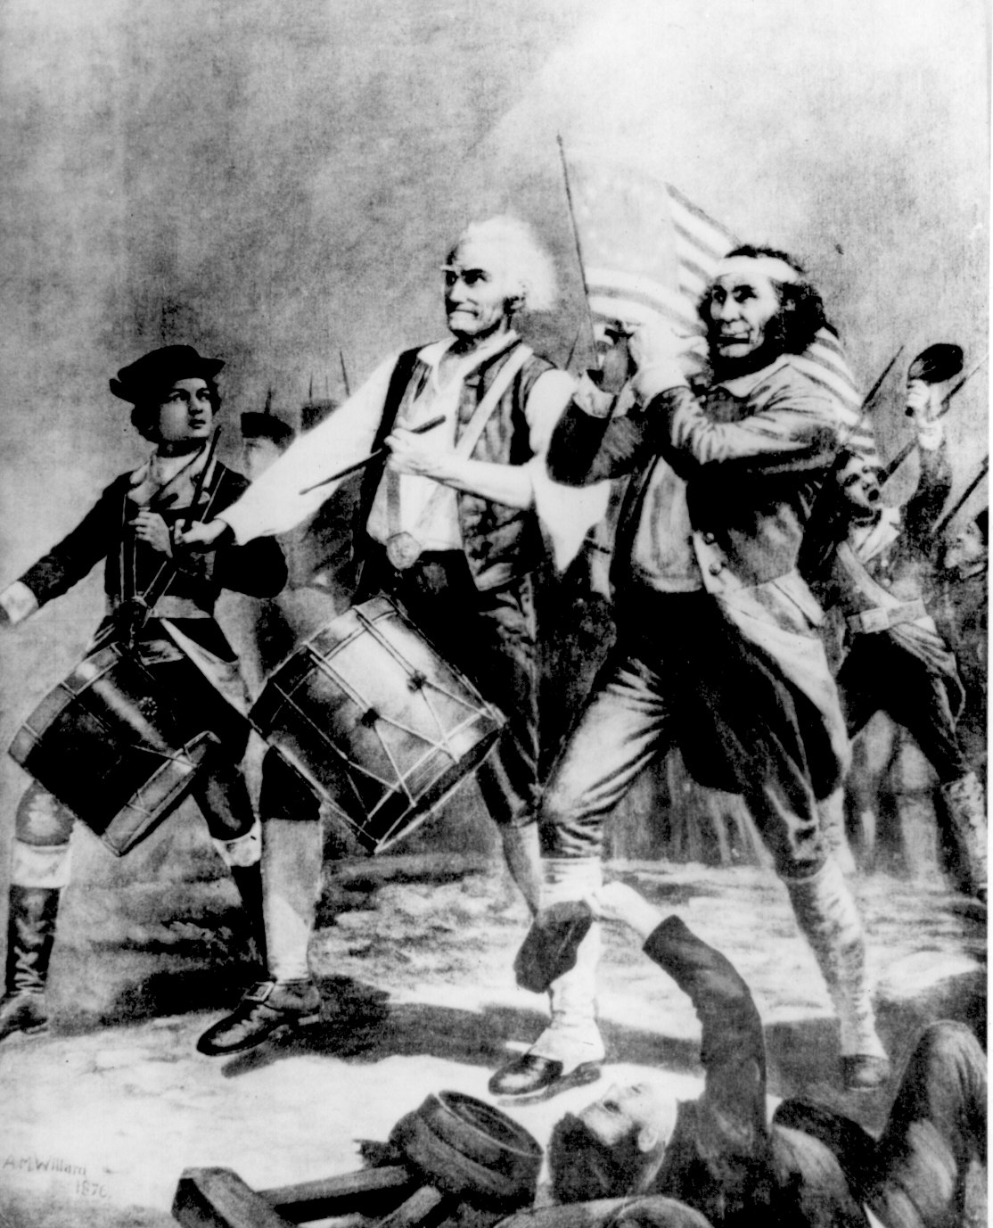

Write a two to three sentence interpretation of this historic painting

1996

Quote of the Day:
“Actions speak louder than words.”

