Big 3 Warm Up 03/31/15

Word of the Day:
Upbraid, transitive verb:

Definition: To scold or criticize harshly.

Example Sentence: That single incident is the only time I can remember my father upbraiding me for my dismal performance as a midshipman.

Use the word of the day in a sentence and underline the word.

World History/Government Trivia:

Who gave our country the name, the United States of America?

Picture Response:
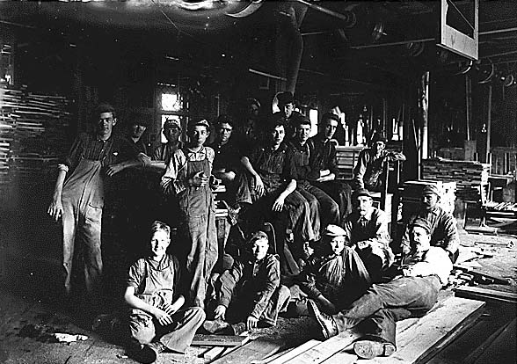

Write a two to three sentence interpretation of this historic painting

Quote of the Day:
“Actions speak louder than words.”

Thomas Paine

