**Big 3 Warm Up 03/20/13**

**Word of the Day:**

### Refrain • verb and noun

Definition(s):

**verb:** resist doing something  
**verb:** choose not to consume  
**noun:** the part of a song where a soloist is joined by a group of singers

Example: “It has been a frequent refrain of Armstrong and his representatives over the years that Lance Armstrong has never had a positive drug test,” the report said.

Use the word of the day in a sentence and underline the word.

**Government Trivia:**

From east to west this state is the widest state in the United States and is the worldwide leader in harvesting macadamia nuts and orchids. What state am I referring to?

**Picture Response:**

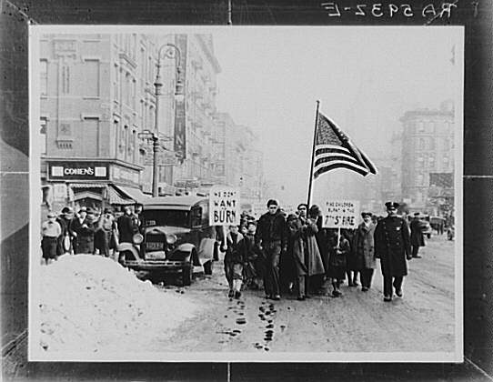

**Write a two to three sentence interpretation of this historic painting**

**Quote of the Day:**

**“Actions speak louder than words.”**

[**http://www.50states.com/facts/michigan.htm#.UIkcR2fiGso**](http://www.50states.com/facts/michigan.htm#.UIkcR2fiGso)