Big 3 Warm Up 03/18/13

Word of the Day:
Polymath, noun:

Definition: A person of great or varied learning; one acquainted with various subjects of study.

Example Sentence: A century after Aristotle, in 240 B.C., a brilliant polymath, Eratosthenes, is appointed chief librarian of the Museum at Alexandria--the most cosmopolitan city and center of learning in the Mediterranean world.

Use the word of the day in a sentence and underline the word.

Government Trivia:

What house is the second most visited American home in the United States--outdrawn only by the White House?

Picture Response:
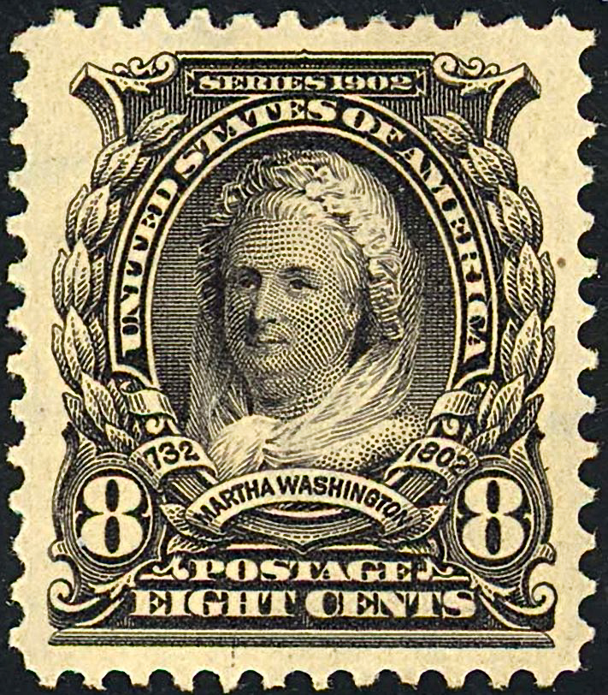

Write a two to three sentence interpretation of this historic painting

Quote of the Day:
“Actions speak louder than words.”

Graceland, the home of Elvis Presley in Memphis, Tennessee

