8th Grade Social Studies Mid-Term Study Guide
Answer the questions below
What was the original purpose of Columbus’ voyage in 1492?

What were the deadly effects from the Columbian Exchange had deadly effects?

Describe the Columbian Exchange

What is true of the Jamestown Colony?

What was life like in the early years of the Jamestown Colony?

Why did Jamestown colonist use indentured servants and African slaves as workers?

What was the Great Awakening?

Who was a minister during the Great Awakening and who delivered the “Sinners in the Hands of an Angry God” sermon?

Who were the Puritans?

Describe and explain the differences between the Puritans and Pilgrims?

According to the Declaration of Independence, what are the rights that all men are given by their Creator?

What is said in the Declaration about all men?

Who was the main author of the Declaration of Independence?

What were the main reasons on why the Declaration of Independence was written?

According to the Declaration of Independence, from where do governments get their power?

What were the causes that lead up to the British and Minutemen fighting in the battles of Lexington and Concord?
Why did the British march to the town of Concord?
Those colonists who supported independence and fought against the British were called?
Who were the Hessians?
Why was the battle of Saratoga the turning point for the Patriots and Americans?
What happened at the battle of Trenton?
Why was the battle of Yorktown so significant?
Describe the strength and weakness of the Articles of Confederation
What is not true or false about the Articles of Confederation?
What was the major weakness of the Articles of Confederation?
Explain the Great Compromise or as it was known as the Connecticut Compromise?
What was the Three-Fifth’s Compromise?
Who were the Federalists and what did they believe in?
What did the Anti-Federalists want to be included in the Constitution?
What individual rights does the first amendment protect?
What are the differences between the 4th and 5th amendments?

Be able to explain, know, understand, and answer any questions pertaining to the below events, movements, ideas, and beliefs
The Columbian Exchange
The Middle Passage
The Great Awakening
Manifest Destiny
Be able to explain and answer questions pertaining to the Colombian Exchange
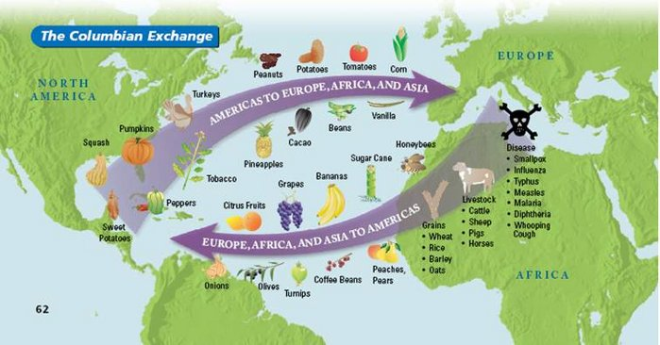

Know these Key Terms:

Consumer
Producer
Supply
Demand
Export
Imports
Scarcity
Opportunity Cost

