REVIEW & OUTLOOK

The Ebola Twilight of Public Institutions

The WHO and CDC are failing in their core health mission.
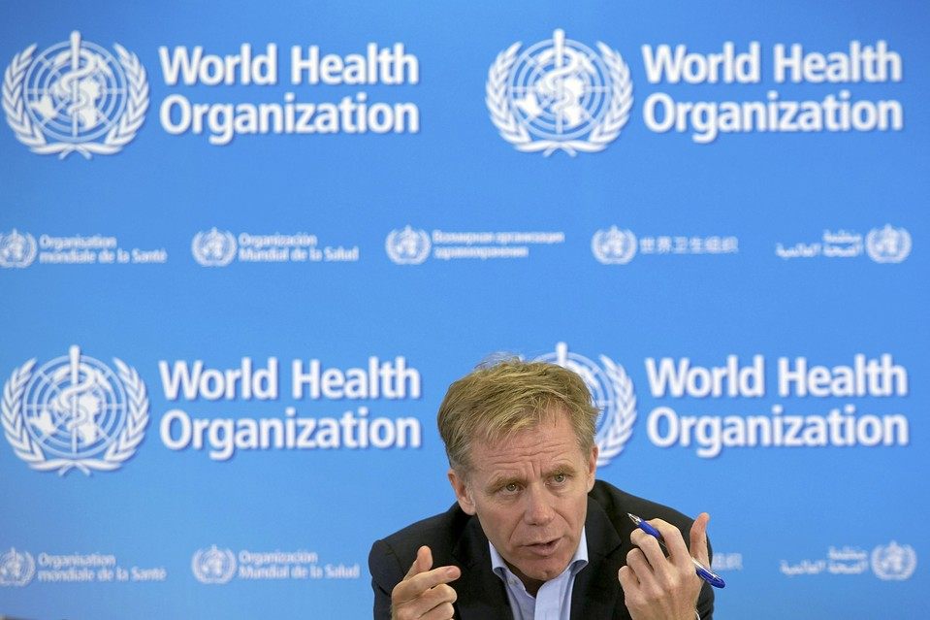ENLARGE
Bruce Aylward, World Health Organization assistant Director General in charge of the operational response to Ebola during a news briefing at the WHO headquarters in Geneva on Tuesday. REUTERS
Updated Oct. 16, 2014 10:30 p.m. ET
On Wednesday the World Health Organization warned of the threat of a global plague, which can cause “vomiting, marked hypocalcemia, metabolic acidosis, convulsions and, in rare cases, even death.” Ebola? No, the WHO culprit is the overconsumption of energy drinks.
The Ebola catastrophe in West Africa has now claimed more than 4,500 lives and the disease continues to spread geometrically, while an outbreak in a major European or North American city would lead to more severe economic dislocation. But the tragedy is also ruthlessly exposing the decay of the once-eminent public institutions that were established to contain such transnational contagions—organizations both international and domestic.
The United Nations-run WHO has long been a growing irrelevance, as director-general Margaret Chan spent the week not in Monrovia but Moscow, pontificating at a WHO conference aimed at raising global tobacco taxes. More disquieting are the failures of the Centers for Disease Control and Prevention and the rest of the American public health establishment, which is supposed to be run by the government’s finest.

Opinion Video
Editorial Board Member Joe Rago on the second U.S. health worker diagnosed with the deadly virus at the Texas Health Presbyterian hospital. Photo credit: Associated Press.
Yet on Wednesday it emerged that a second person has been infected with Ebola on U.S. soil, another nurse who treated the Liberian national who died of the virus in Texas. The night before she came down with fever and tested positive, she returned on a flight to Dallas-Forth Worth from a weekend in Cleveland along with 132 other passengers and crew.
CDC director Thomas Frieden said that health-care workers were not under active Ebola observation like the Dallas civilians who may have been exposed, but were instead “self monitoring” for symptoms. They were not supposed to travel on public transportation or commercial flights. Nor could he explain the new cases of transmission except as an unspecified “breach of protocol,” perhaps when they removed hazmat suits.
The new victim was not vomiting or bleeding in the air (how reassuring) and thus was unlikely contagious. Yet the CDC claims the Dallas Ebola burst—while still minor—is under control except when it isn’t. It would be easier to trust the official appeals for calm if officials did not keep supplying reasons to believe otherwise, or behaving as if it is absurd to fear a pathogen that liquefies internal organs.
An Ebola outbreak on the Eastern seaboard or some other densely populated region could well cost billions of dollars to contain and perhaps throw the economy into recession, akin to the 2009 swine flu pandemic in Asia. The possibility is very remote, and Washington is marginally more accountable than China. Then again, the CDC said domestic cases were improbable too.
President Obama cancelled campaign events for an emergency White House meeting Wednesday and promised a “much more aggressive” U.S. response. “These protocols work,” he added. But he had heralded “an all-hands-on-deck approach” earlier this month “to make sure that we are addressing this as aggressively as possible,” and in September he had said that “the chances of an Ebola outbreak here in the United States are extremely low.”
Mr. Obama would have done more good by condemning the WHO. Responding to microbiological disasters is supposedly why the WHO exists—and tens of thousands of people may die as a result of the U.N.’s failure of this test of its mission, priorities and competence. “Yes, Ebola is truly an issue of international concern,” Dr. Chan told reporters in Russia, “but tobacco—if we put the evidence on the table—tobacco control is still the most cost-effective and efficient way of reducing unnecessary diseases and deaths arising from using such harmful products.”
Since the 1990s, the WHO has gradually transformed itself from a disease fighter to what Dr. Chan calls “a normative agency” that makes international public health rules and promotes political goals like universal coverage. “That represented a very significant change over prior WHO policies,” says Laurie Garrett of the Council on Foreign Relations, who calls the WHO’s response to the epidemic “just shameful.”
The WHO rebooted its emergency “roadmap” this summer to include assisting local hospitals, dispensing gear and (of course) “raising awareness” of Ebola. But mostly the agency thinks the emergency is due to inadequate funding of about $2 billion a year.
The reality is that world-wide public health spending has quadrupled to $27 billion in the last two decades, but this tide of resources has bypassed the WHO bureaucracy to flow through other institutions like the World Bank or George W. Bush ’s President’s Emergency Plan for AIDS Relief, and especially philanthropies like the Bill and Melinda Gates Foundation. WHO’s budget is nearly twice that of Médecins Sans Frontières, which has provided far more relief to West Africa.
The World Health Organization ought to be defunded to discipline its ineptitude and frivolity. Start with the caffeine division, and hand the money to a more serious and capable institution. The problem these days is identifying which that might be.

