No More Ebola Whac-A-Mole

The fire-brigade approach clearly isn’t working. A sustained, coherent policy is vital to preventing pandemics.
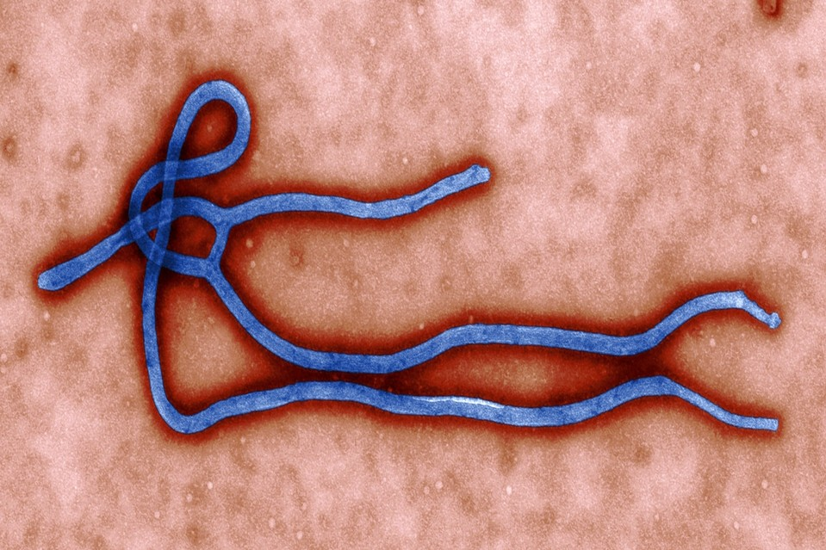ENLARGE
The Ebola virus in an image provided by the Centers for Disease Control. ASSOCIATED PRESS
By
NATHAN WOLFE
Oct. 13, 2014 7:04 p.m. ET
313 COMMENTS
Ebola has killed more than 4,000 people, and the number of cases in Liberia and Sierra Leone is growing rapidly. We don’t know how many will ultimately die. But we do know that unless the world takes broader, more coordinated steps aimed at anticipating outbreaks like Ebola and controlling them early, we’ll be vulnerable to this and other devastating diseases.
This vulnerability reflects a world that is increasingly interconnected and susceptible to potentially pandemic viruses that are transmitted to humans from wild animals. In the past year, for example, we’ve witnessed the emergence of MERS and H7N9 as well as Ebola—and despite the understandable focus on Ebola, the risk of a serious outbreak from these other viruses has not disappeared.
Guarding against the threat means putting in place robust, resilient laboratory and surveillance infrastructure in those parts of the world—Africa and elsewhere, most notably Asia—most susceptible to viral epidemics, and we must support regional scientists and health experts who will sustain this infrastructure at all times. Local political leaders have to buy in to this effort, and countries and governmental agencies in the region will need to coordinate their work.
The growing international response to the West African epidemic is valiant, but it is after the fact—a fire-brigade model. That has to change, or the world will continue to be stuck in a dangerous game of pandemic Whac-A-Mole.
Pandemics are generally not random, one-off events. Close viral cousins of HIV, for example, were jumping for many years from chimpanzees to people in Central Africa before a strain emerged that led to the AIDS pandemic. Ebola outbreaks have been common in recent years. In August, while the world focused on West Africa, a second outbreak of Ebola occurred in the Democratic Republic of Congo. It emerged from an animal-to-human transmission that was unrelated to the West African epidemic.
The Ebola outbreak in Congo, unlike the one in West Africa, occurred in a rural area without easy connections to large population centers. But the way it was controlled shows what is possible regarding futures eruptions of infectious disease.
Congo has years of experience fighting this disease: It has world-class Ebola experts who have responded to countless outbreaks, as well as multiple, national-level laboratories that are devoted to the diagnosis of viruses. When people in Congo began falling ill this summer, local labs within a week were able to determine both that Ebola was the cause and that the virus was distinct from the West African epidemic. The Congolese response included immediate site visits and the deployment of a mobile lab for on-site diagnostics, reducing response time, and the effective isolation of Ebola cases.
In regions that are susceptible to pandemics, it will be crucial in the future to coordinate the efforts of different branches of governments. A model for this is Cameroon, where the government has a National Emergency Committee for Pandemics & Epidemics and a National Program for Zoonosis Prevention and Control, both aimed at infectious agents including Ebola and others that move from animals to humans. These organizations, the product of efforts begun six years ago, help to integrate the monitoring of animal and human diseases, and have advocated this year for dedicated training and early shipment of critical equipment in anticipation of the potential regional spread of Ebola. The Cameroon emergency committee has also helped coordinate efforts this year to fight against cholera and polio.
Even when national and regional systems are in place, there will be times when the developed-world cavalry will need to rush to the rescue, as it is now. But ultimately there are more important ways that wealthy nations can assist.
For example, the disease surveillance and diagnostic systems in Cameroon and Congo have been facilitated for over a decade by financial and technical support from American governmental agencies, groups within the Defense Department and United States Agency for International Development (USAID), implemented in part by my company. More work of this kind is needed, and it is vital that other countries get more involved in this kind of effort.
Today, the length of time needed for foreign aid to reach its destination, as well as the ability of countries to rapidly and effectively use assistance, pose real problems in need of solutions. Innovative financial tools such as parametric catastrophe bonds—an insurance-like instrument—could at least improve the speed of funding. Payment of these bonds is triggered based on the measurement of an actual hazard, such as wind speed in the case of a hurricane, and so they are paid immediately rather than waiting for a claim based on damages. In the case of outbreaks, the bonds would require more standardized and widely distributed measures of early detection, but since such measures are needed anyway, the development of such financial instruments and the push for improved surveillance systems could work hand in hand.
Ebola is not the first virus to threaten the world, and it won’t be the last. Stopping the current epidemic is vital, but the world can’t afford to go to sleep after it is stopped. Unless we prepare for the next epidemic, we will find ourselves forever nailing down outbreaks just in time to see the next ones pop up.
Mr. Wolfe is the founder and CEO of Metabiota, which develops systems for monitoring and managing disease spread.

