World History Timeline Assignment

Overview:
Each student will pick a Significant Event and or series of events within chapters 27 and 28. You will research your event in your textbook, Media Center resources, and online (Be careful to use valid sites - check me first). Your work may be posted around the classroom, so please pay careful attention to presentation.

Objective:
Identify the significant event or events that have occurred during that time that had a substantial impact on the landscape, people, and or countries that were indirectly or directly impacted by event and or events.

Directions:
A: Significant Event and or series of events -Choose a Significant Event for example in World History that is covered in your textbook in chapters 27 and 28. Only one person can cover a specific topic and or event. All must have different significant events.

B: Research – You may be able to use the Media Center resources and the Internet to find the summary information. Before and after school, you can speak with me the day before about the possibility of using the adjacent room to my classroom that has computer/internet access.

C: Illustration - On an 8x11 sheet of blank paper, create an illustration of this significant historical event or events. You might include pictures, clipart, famous quotes, and more. This paper is to be matted on a piece of construction paper.

D: Date(s) – Type the date or dates in for example “Europe Revolutions of 1848“World War II 1941” (at least 48 Font Size) in a specific format.

E: On a separate sheet of paper, please list sources and references that you may have used

List below is just ONE example but does not mean and or should limit your creativity in you making up your own design, style, etc.

I will discuss and give you the grading breakdown in class of this assignment.

*I may modify this assignment at a later time and date to best benefit the student.

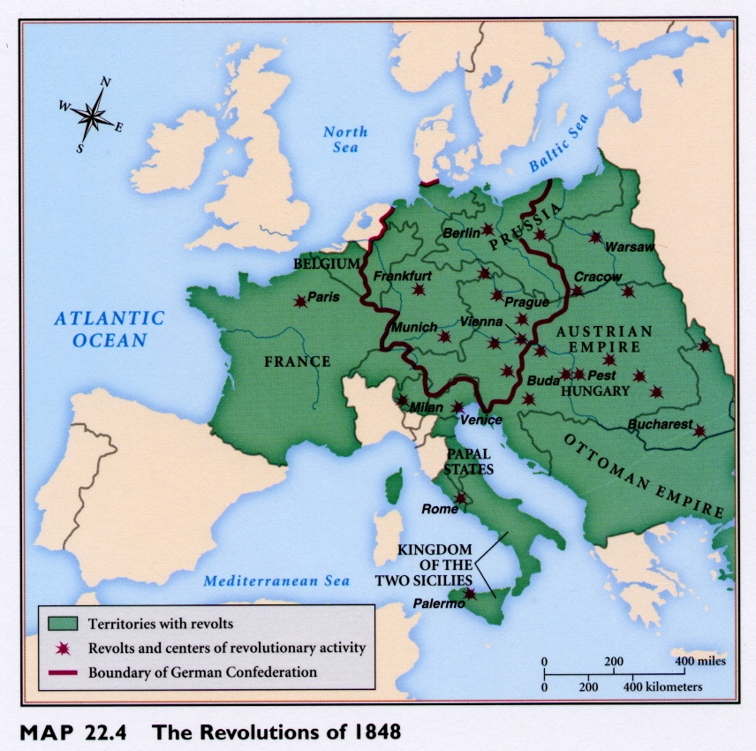

Source link: http://fc.greensboroday.org/~ldrewiczewing/Revolutions1848.JPG

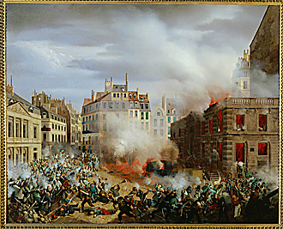
Source Link: http://www.lessing-photo.com/p2/260305/26030526.jpg
Example:
European Revolutions of 1848
Timeline

March 3, 1848: Revolution broke out in the Rhineland.
March 12, 1848: Revolution broke out in Vienna.
March 15, 1848: Revolution broke out in Berlin.
March 18, 1848: Revolution broke out in Milan. The papal states were given a constitution and the Milanese defeated the Austrians.
March 22, 1848: Revolution broke out in Venice and the Venetian Republic was reestablished.
May, 1848: Piedmont declared war on Austria.
July, 1848: Austrians attack Piedmont and overwhelmingly defeat it. Troops march into Milan.

