American Government: **THIRTEEN DAYS**

Description: It's 1962, the height of the Cold War. The U.S. has caught the Russians secretly installing nuclear missiles on the island of Cuba. President John F. Kennedy convenes a team of advisors to help him decide how to respond. The challenge: how to force the Russians to withdraw the missiles without provoking nuclear war.

"Thirteen Days" shows President Kennedy's wise leadership in meeting this challenge as he resisted the demands for air strikes and for invasion. If he had not, we would all be living in a post-nuclear war world, except there would be hundreds of millions fewer of us, especially in the U.S., Cuba, Russia, and Europe.

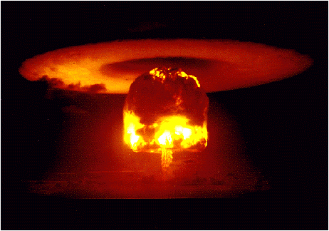

Benefits of the Movie: "Thirteen Days" is the story of mankind's closest brush with nuclear Armageddon. Many events are portrayed exactly as they occurred. The movie captures the tension that the crisis provoked and provides an example of how foreign policy was made in the last half of the 20th century. Supplemented with the information provided in this Learning Guide, the film shows how wise leadership during the crisis saved the world from nuclear war, while mistakes and errors in judgment led to the crisis. The film is an excellent platform for debates about the Cuban Missile Crisis, nuclear weapons policy during the Cold War, and current foreign policy issues.

Possible Problems: SUBSTANTIAL. "Thirteen Days" conveys several major historical misimpressions. First, the movie incorrectly assumes the U.S. government believed that the missiles in Cuba substantially altered the balance of nuclear power and made a Russian first strike with nuclear weapons more likely. President Kennedy did not believe this. His reasons for risking nuclear war to remove the missiles, while important, were different and less compelling. A second misimpression arises from the exaggeration of the tension between the U.S. military and President Kennedy. Third, because the film focuses on the thirteen days of the crisis, it ignores the fact that U.S. foreign policy contributed to the atmosphere in which the Russians tried to place missiles in Cuba. "Thirteen Days" can be a valuable supplement the study of the Cold War, but only if these misimpressions are brought out and discussed. The Helpful Background section of this Learning Guide provides the information necessary to make these corrections.

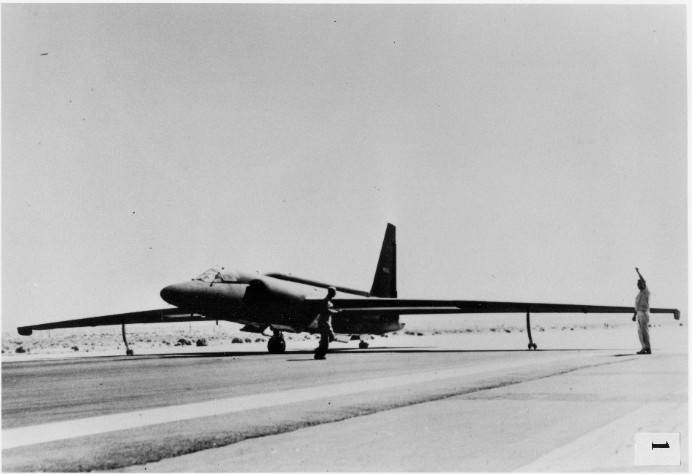

U-2 Spy Plane

Helpful Background:

WERE WE REALLY THAT CLOSE TO NUCLEAR WAR?

Yes. We were very, very, close.

As terrified as the world was in October 1962, not even the policy-makers had realized how close to disaster the situation really was. Kennedy thought that the likelihood of nuclear war was 1 in 3, but the administration did not know many things. For example, it believed that the missiles were not operational and that only 2-3,000 Soviet personnel were in place. Accordingly, the air strike was planned for the 30th, before any nuclear warheads could be installed. In 1991-92, Soviet officials revealed that 42 [missiles] had been in place and fully operational. These could obliterate US cities up to the Canadian border. These sites were guarded by 40,000 Soviet combat troops. Further, 9 SRBMs [Short Range Ballistic Missiles] were ready to be used against the Americans in case of an invasion. The Soviets had tactical nuclear weapons that the local commanders were authorized to use to repel an attack. After he learned of this in 1992, a shaken [Robert] McNamara [Kennedy's Secretary of Defense] told reporters, "This is horrifying. It meant that had a US invasion been carried out... there was a 99 percent probability that nuclear war would have been initiated."

HISTORICAL ANTECEDENTS OF THE CUBAN MISSILE CRISIS

Although the crisis began and ended in October of 1962, the story began much earlier. Almost immediately after World War II, relations between the Soviet Union and the U.S. deteriorated, ending the cooperation which enabled the Allies to defeat Nazi Germany. The Russians did not withdraw their forces from Eastern Europe. Russian occupying forces overstayed their tour of duty in the Middle East. The Russians supported Communist revolutionaries in Greece. Britain and America thwarted the expansion of the Azerbaijani Soviet Republic into Iran and began the policy of containment attempting to restrict Soviet expansion.

As the Cold War took hold, Americans became alarmed at the spread of Communist regimes in East Europe and East Asia. The Soviets were worried about postwar unity among the U.S. and powerful West European nations. Both the Communist bloc and the capitalist democracies lurched from crisis to crisis. These ranged from the Soviet blockade of Berlin, the Korean War, American spy planes crossing Russian airspace, Chinese shelling of Taiwanese islands Quemoy and Matsu, and the confrontation between Soviet ally Egypt and Western allies Israel, France and Britain over the Suez Canal.

Both sides developed highly destructive nuclear weapons. At the time of the crisis, Russia had almost 40 Intercontinental Ballistic Missiles (ICBMs) and numerous Intermediate Range Ballistic Missiles (IRBMs). The IRBMs could not reach the U.S. (other than Alaska) but they could reach Western Europe. With these missiles and its bomber fleet, the Soviet Union could hit the U.S. and its allies in Europe with approximately 250 nuclear weapons, enough to take out all of the major cities. Well over a hundred million people would have been killed in the U.S. and the NATO countries. The U.S., for its part, had approximately 170 ICBMs and taking all delivery devices into consideration, including long range bombers, IRBMs and submarine based missiles, the U.S. could deliver some 3,000 nuclear bombs into Russia. While there were defenses to the long range bombers, there were no defenses to ICBMs or IRBMs. (There are still no defenses to these weapons.)

In 1962 while the U.S. government knew that its nuclear forces were much stronger than those of the Soviet Union, it realized that losing its major cities with casualties approaching 100,000,000 people was not acceptable. In addition, through treaty obligations and as a practical matter, no U.S. government could permit Europe to be destroyed. However, the Soviets acutely felt the inferiority of their nuclear deterrent. The effort to place missiles in Cuba was an effort by the Russians to improve their nuclear capability quickly and inexpensively.

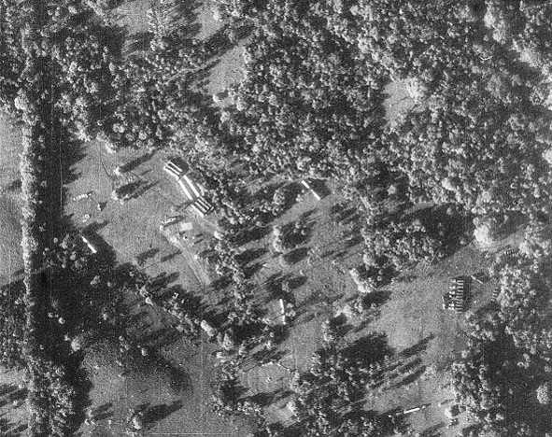

Missile transporters and missile-ready tents where fueling and maintenance took place.

The U.S., under the Kennedy Administration, increased military expenditures and increased its lead in nuclear weapons over the Russians, while, at the same time, refusing to disavow a nuclear first strike. In addition, despite the Bay of Pigs debacle, the U.S. continued its efforts to destabilize Cuba and to assassinate its dictator, Fidel Castro.

The Soviet leadership didn't realize how much the U.S. feared Russia's nuclear deterrent. In an attempt to redress the imbalance in nuclear missiles and ensure that the U.S. would not mount another Cuban invasion, Nikita Khrushchev, dictator of the Soviet Union, began a program to secretly place intermediate range nuclear missiles in Cuba. These missiles would be able to reach almost all of the continental U.S. The CIA learned of suspicious activity from intelligence sources on the island and the U.S. sent U-2 spy planes to investigate.

When a U-2 came back with photographs of missile sites under construction, President Kennedy convened his advisors before announcing the discovery to the world. While some recommended diplomacy, others pressed for military options, such as air strikes or invasion of Cuba. President Kennedy adopted a middle approach in which the U.S. Navy quarantined the island of Cuba, preventing any additional missiles or offensive weapons from reaching the island. In the meantime, the U.S. mounted a diplomatic offensive attempting to use world opinion to pressure the Soviets to remove the missiles. Soviet ships tested the blockade, but ultimately chose not to challenge the quarantine. The U.S. for its part allowed ships with food and fuel through the quarantine. Acting without Moscow's approval, a Soviet surface-to-air missile (SAM) battery shot down a U-2 spy plane over Cuba, killing the pilot. In secret negotiations, Khrushchev agreed to dismantle the missiles in Cuba. President Kennedy pledged not invade Cuba. In a confidential side agreement, the U.S. promised future removal of 15 obsolete Jupiter missiles from Turkey. President Kennedy had ordered these missiles removed months before but, because of objections from the Turks and bureaucratic inertia, the missiles remained in place.

After the Cuban Missile Crisis, the superpowers moved to reduce the risk of a nuclear confrontation. Difficulties in Communications encountered during the crisis led to the installation of direct telephone Communications between the leaders to avoid any future misunderstandings. In subsequent years, the countries negotiated a nuclear test ban treaty. Future presidents and Soviet leaders conducted Strategic Arms Limitation Talks (SALT) in the 1960s and 1970s to limit the number of nuclear warheads poised to strike the other side. The Nuclear Non-Proliferation Treaty in 1969 attempted to limit the spread of nuclear weapons to other countries. President Ronald Reagan and Soviet General Secretary of the Communist Party Mikhail Gorbachev negotiated the INF Treaty in the late 1980s, which began the elimination of intermediate range nuclear missiles. Other American presidents and Russian leaders have worked to reduce nuclear weapons through a pair of Strategic Arms Reduction Treaties (START I & II).

Never again would America and Russia come to the same level of threat that characterized those thirteen days in October of 1962.

The following additional background will be helpful in understanding the concerns of the participants and their statements, as set out in the film.

*Munich and Appeasement:* In the 1930s a resurgent Nazi Germany violated the restrictions on its military set out in the Versailles treaty that ended WW I. Looking to expand, Germany demanded that Czechoslovakia cede to it a part of Czech territory called the Sudentenland in which approximately 3 million ethnic Germans (23% of the population) lived. Hitler claimed that they were oppressed by the Czech majority. At a conference in Munich held to consider Hitler's demands, the leaders of the Western powers (France and Great Britain) agreed to the dismemberment of Czechoslovakia to appease Hitler. Hitler promised that if Germany absorbed the Sudentenland, it would seek no additional territory. British Prime Minister Neville Chamberlain returned home saying that he brought "peace in our time." He was wrong. The Munich conference convinced Hitler that France and Britain were weak, leading directly to the German invasion of Poland. Hitler thought France and England would do nothing. Realizing their mistake with Czechoslovakia, Britain and France declared war on Germany. World War II had begun. "Munich" was thereafter cited as the classic historical example of encouraging an aggressor by giving in to its demands.

"Munich" also had a personal meaning for the Kennedy brothers. Their father, Joseph P. Kennedy, had been one of the few millionaires to back Franklin Roosevelt in the 1932 election. Roosevelt appointed Kennedy ambassador to Britain. In private cables to the State Department and in public speeches, Ambassador Kennedy supported the Munich compromise. From the time of Munich until long after the U.S. had declared war on Germany, Joe Kennedy advocated a compromise with Hitler and an isolationist foreign policy. President Kennedy, as a young man, had written a best selling book criticizing appeasement. Despite this fact, until the end of the missile crisis, John Kennedy carried the burden of his father's stand in favor of appeasement.

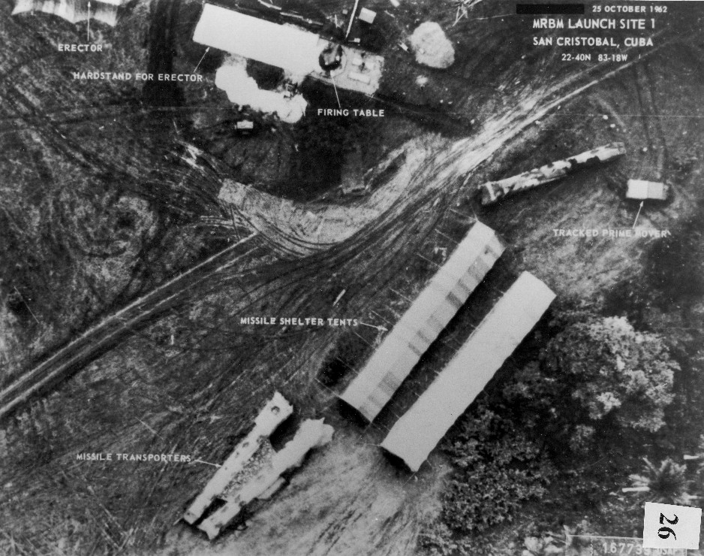

*Pearl Harbor*: On December 7, 1941, the Imperial Japanese Navy mounted a sneak attack on the U.S. naval base at Pearl Harbor, Hawaii. There had been no warning. Japan had not declared war on the U.S. President Roosevelt labeled December 7 as "a date which will live in infamy." Pearl Harbor had two effects on the Cuban Missile Crisis. First, the lesson that an adversary might mount a sneak attack had been absorbed by U.S. intelligence and was partially responsible for the U-2 flights and aerial reconnaissance that discovered the missiles. Second, throughout the Excomm deliberations, the fear of losing the moral high ground by mounting a sneak attack on the missile bases served as a restraint on the policy makers.

*World War II:* The men in the Excomm had personal memories of World War II and the Korean War. Many had experienced war first hand. President Kennedy, for example, volunteered for combat, hiding back problems that would easily have won him an exemption from military service. When the PT boat he commanded was rammed and sunk by a Japanese destroyer, Kennedy led his men to a small island several miles away, saving one severely injured sailor by holding the strap to a life preserver between his teeth while he swam to shore. Kennedy was awarded the Navy and Marine Corps Medal for his leadership and courage. Khrushchev, too, had personally served in the Red Army during WW II. Russia had suffered more from the war than any other nation in terms of casualties and property destruction. The men making the decisions during the Cuban Missile Crisis, in Moscow and in the U.S., knew first hand the horrific effects of a major war. Importantly, Fidel Castro, had experience only in a civil war that was relatively painless. As will be seen, Castro's willingness to provoke a nuclear war was one of the destabilizing factors in the Crisis.

*Berlin and NATO:* After WW II, the Allies (U.S., U.S.S.R, Britain, and France) divided the German capital, the city of Berlin, into four zones of occupation. Germany itself was also carved up into zones. Berlin was located deep within the Russian zone. Shortly after the war, the Western powers consolidated their zones into a new state called West Germany. The Russians established a Communist state in their zone called East Germany. The Russian sector of Berlin became the capital of East Germany. The Western sector of Berlin, despite the fact that it was deep within East German territory, became a part of West Germany. The status, and as time went on, the prosperity of West Berlin increasingly annoyed the Russians and the East Germans. In 1948 Stalin suddenly stopped permitting access by land to West Berlin. The Western powers, led by the U.S., mounted an effective airlift to bring supplies to the city. The Western democracies made it clear that if the Soviets interfered with the airlift there would be war. Eventually, when the Russians became convinced that the West would not back down, they dropped the blockade. West Berlin became a symbol of U.S. determination to resist Soviet expansion. As such, it was a cornerstone of the Western policy of "containment" which sought to block the expansion of Russian influence and Communist ideology.

Through the years, West Berlin became a wealthy glittering city standing in stark contrast to the drab and relatively impoverished life of East Germany. West Germany also became an economic powerhouse, dwarfing its Eastern rival. Many East Germans, seeking a better life in the West, fled to West Berlin on their way to West Germany. Increasingly, well educated and highly trained East Germans used this escape route. The situation had become intolerable for the Russians and East Germans.

Khrushchev had committed his personal prestige and that of the Soviet Union to action against Western interests in Berlin. Cable U.S. Ambassador to Russia Llewelyn "Tommy" Thompson to Kennedy, 1961. As Khrushchev colorfully put it, Berlin was a "bone in the throat" of the Soviet Union. The Soviet Foreign Minister Andrei Gromyko stated to President Kennedy when they met during the crisis that after the November elections in the U.S., the Russians would be "compelled" to "take steps to end the Western presence in Berlin. The Kennedy Tapes: Inside the White House During the Cuban Missile Crisis May and Zelikow (hereinafter " The Kennedy Tapes) pg. 106.

In August of 1961, to stop the exodus through Berlin to West Germany, the Russians and East Germans sealed off West Berlin and began construction of the Berlin Wall. West Berlin remained sealed off until 1989.

The military situation of West Berlin was strategically untenable. Its defenders were surrounded on all sides by East Germany and superior numbers of Russian and East German troops. If attacked, the city's defenders could only delay the inevitable. Both the Communists and NATO recognized this fact. The NATO allies would not tolerate the loss of a West Berlin. If the U.S. allowed the Russians to take West Berlin, its Western European partners (particularly, England and France) would feel betrayed and the NATO alliance severely weakened, if not destroyed. (This was another major reason why the Russians wanted to change the situation in West Berlin.) In response to the need of the Western Europeans for maintenance of the status quo in Berlin and because of the West's inability to defend the city using conventional forces, U.S. policy, enunciated by President Kennedy, was that West Berlin would be defended, if necessary, with a nuclear strike on the Soviet Union.

West Berlin was more important to the Russians and the Europeans than was Cuba. For the U.S., the maintenance of the NATO alliance was, militarily, more important than removing the missiles from Cuba. However, the U.S. public would not tolerate the presence of Russian missiles in the Western Hemisphere, nor would the U.S. have had any credibility with its allies or its foes if it permitted missiles to be secretly introduced into the island.

*U.S. Policy Toward Cuba and The Bay of Pigs Invasion:* In April of 1961 the CIA, with President Kennedy's approval, mounted an invasion of Cuba using Cuban exiles as the initial landing force. The invasion was poorly planned and quickly crushed. President Kennedy had relied upon the advice of experienced men in the government who told him that the invasion would succeed. He had ignored warnings from many that the plan was flawed. The invasion was an unmitigated disaster for the U.S. government and for President Kennedy. The responsible officials, the head of the CIA (Allen Dulles) and an assistant (Bissell) were told by President Kennedy that they were to resign after a decent interval. The Kennedy Tapes, p. xlii.

After the Bay of Pigs invasion, the CIA developed Operation Mongoose which actively tried to destabilize the Cuban regime and assassinate Castro. Robert Kennedy, at the direction of the President, personally supervised these activities and was very persistent in pushing the CIA for more aggressive action against Cuba and against Castro personally. This was a massive operation with 6000 acts of sabotage committed in Cuba.

President Kennedy Institutes New Procedures to Develop and Assess Foreign Policy Options: After the Bay of Pigs, President Kennedy analyzed his decision making process. He now knew that before making important decisions he needed to explore the possible consequences of each alternative course of action and seek advice from a variety of sources, inside government and out. He used this process in the summer of 1961 when the Soviets made their first threats against West Berlin. The Excomm deliberations shown in the film were the means by which President Kennedy obtained advice during the Cuban Missile Crisis.

The Excomm was an unusual body because it included representatives from outside the government, in this case former Secretary of State Dean Acheson. Governmental officials from agencies not usually involved in critical military decisions were included in the committee. Chief among these was Secretary of the Treasury Douglas Dillon, a Republican. Finally, all types of views were solicited. As shown in the movie, Adlai Stevenson, ambassador to the U.N. and former two-time Democratic candidate for President, advocated appeasement of the Russians. He was alone in this position. President Kennedy protected Stevenson from being ousted from the Excomm and removed as Ambassador to the U.N., as Bobby Kennedy advised. In the end, Stevenson proved immensely valuable to the U.S. by dramatically showing that the Russians were lying to the world about the missiles. His speech was the single most important victory in the propaganda war that was such an important part of the Cuban Missile Crisis.

*Khrushchev:* In contrast to the way in which President Kennedy reached out to a broad array of advisors for help in making decisions in the crisis, Chairman Khrushchev had very few advisors. He viewed the members of the Presidium, which would have provided the most experienced and logical pool of advisors, as political adversaries. For more on Khrushchev and the fact that he conceived of the policy and extended the crisis to attempt to obtain more leverage against the U.S., see discussion below.

President Kennedy and Khrushchev had spent a considerable amount of time together in Geneva. Kennedy was appalled at Khrushchev's ruthlessness and barbarity. The Kennedy Tapes page xlvi. As it turned out, when faced with the probability that his ploy in Cuba would lead to nuclear war, and given an out by the U.S., Khrushchev acted in a civilized manner and withdrew the missiles.

IN PRESIDENT KENNEDY'S OWN WORDS

President Kennedy secretly made tapes of some of the meetings of the Excomm. On one meeting he stated:

Last month I said we weren't going to [allow offensive missiles on the island of Cuba]. I should have said that we don't care. But when we said we're not going to [allow missiles in Cuba] and then they go ahead and do it, and then we do nothing, then I would think that our risks increase.

I agree, what difference does it make. They've got enough to blow us up now anyway, I think it's just a question of ... After all, this is a political struggle as much as military. The Kennedy Tapes, pg. 62. (See also pages 116 and 117 in which President Kennedy disagrees with assessments by Generals Wheeler and LeMay that the missiles in Cuba significantly changed the military situation. "... [N]o matter what they put in there, we could live today under. If they don't have enough ICBMs [deployed on Russian soil] today, they're going to have them in a year...." pg. 116. The military view was not monolithic. General Shoup, Commandant of the Marine Corps asserted that the Soviet Union already had sufficient missile capacity to attack the U.S. Ibid.)

Early in the crisis, on October 19, 1962, President Kennedy summarized the situation to the Joint Chiefs of Staff as follows:

First, I think we ought to think of why the Russians did this. Well, actually, it was a rather dangerous but rather useful play of theirs. If we do nothing, they have a missile base there with all the pressure that brings to bear on the United States and damage to our prestige.

If we attack Cuba, the missiles, or Cuba, in any way then it gives them a clear line to take Berlin, as they were able to do in Hungary under the Anglo war in Egypt. We will have been regarded as - they think we've got this fixation about Cuba anyway -- we would be regarded as the trigger-happy Americans who lost Berlin.

We would have no support among our allies. We would affect the West Germans' attitude towards us. And [people would believe] that we let Berlin go because we didn't have the guts to endure a situation in Cuba. After all, Cuba is 5[,000] or 6,000 miles from them. They don't give a damn about Cuba. And they do care about Berlin and about their own security. So they would say that we endangered their interests and security and reunification [of Germany] and all the rest, because of the preemptive action that we took in Cuba. So I think they've got ... I must say I think it's a very satisfactory position from their point of view. ...

And thirdly, if we do nothing, then they'll have these missiles and they'll be able to say that any time we ever try to do anything about Cuba, that they'll fire these missiles. So that I think it's dangerous, but rather satisfactory, from their point of view.

If you take the view, really, that what's basic to them is Berlin and there isn't any doubt [about that]. In every conversation we've had with the Russians, that's what ... Even last night we [Soviet Minister Andre Gromyko and I] talked about Cuba for a while, but Berlin -- that's what Khrushchev's committed himself to personally. So, actually, it's a quite desirable situation from their point of view.

Now that's what makes our problem so difficult. If we go in and take them out on a quick air strike, we neutralize the chance of danger to the United States of these missiles being used, and we prevent a situation from arising, at least within Cuba, where the Cubans themselves have the means of exercising some degree of authority in this hemisphere.

On the other hand, we increase the chance greatly, as I think they -- there's bound to be a reprisal from the Soviet Union, there always is -- of their just going in and taking Berlin by force at some point. Which leaves me only one alternative, which is to fire nuclear weapons -- which is a hell of an alternative -- and begin a nuclear exchange with all this happening.

On the other hand, if we begin the blockade that we're talking about, the chances are they will begin a blockade [of Berlin] and say that we started it. And there'll be some question about the attitude of the Europeans. So that, once again, they will say that there will be this feeling in Europe that the Berlin blockade has been commenced by our blockade.

So, I don't think we've got any satisfactory alternatives. When we balance off that our problem is not merely Cuba but it is also Berlin and when we recognize the importance of Berlin to Europe, and recognize the importance of our allies to us, that's what has made this thing be a dilemma for three days. Otherwise, our answer would be quite easy....

On the other hand, we've go to do something. Because if we do nothing, we're going to have the problem of Berlin anyway. That was very clear last night [in the meeting with Gromyko]. We're going to have this thing stuck right in our guts, in about two months [when U.S. intelligence thought that the IRBMs in Cuba would be operational; in fact they were becoming operational as President Kennedy spoke]. And so we've got to do something. The Kennedy Tapes pp. 111 and 112.

WHY DID KHRUSHCHEV BACK DOWN?

U.S. policy makers rushed to prepare an invasion of the island without knowing that the missiles were operational and that the island was guarded by 40,000 Red Army personnel armed with tactical nuclear weapons (another in a long line of gross U.S. intelligence failures that extend to the present day). Khrushchev, however, was fully aware of all of these dangers. He also knew that there would have been a very strong reaction, probably an all out war, if nuclear weapons were used on U.S. troops.

There was an additional fact that Khrushchev knew that was extremely important and this was a fact he had not understood when he gave the order to put the missiles in Cuba. The U.S. population was unwilling to tolerate hostile nuclear missiles in Cuba. It was therefore impossible for any U.S. government to permit the missiles to remain and the U.S. would go to war, if neccessary, to remove the missiles. The failure to gauge the reaction of ordinary U.S. citizens to the prospect of Russian missiles in Cuba was Khrushchev's key mistake in his planning for the crisis. It was certainly an understandable error for a Russian leader to make. Russia had lived with hostile enemies on its borders for centuries. The U.S. had missiles in countries relatively close to Russia, including Turkey. The Russians had learned to live with these threats. Khrushchev forgot (or never knew and his experts on the U.S. didn't tell him) that the U.S. had not been invaded since 1812 and that for more than 150 years the U.S. population had felt protected by the oceans separating it from Europe and Asia. By 1962, with the advent of nuclear tipped ballistic missiles, that feeling of insulation may have been irrational, but it was still very real. Khrushchev never dreamed that the U.S. populace would react so dramatically to Russian missiles in Cuba. Nikita Khrushchev and the Creation of A Superpower by Sergei N. Khrushchev, (hereinafter "Khrushchev" pp. 484 & 485. In Sergei Khrushchev's words the reaction of the U.S. citizenry was "Father's miscalculation ...")

In addition, Communications in 1962 were not what they are today. As a result, Khrushchev had only incomplete control over the Russian military units in Cuba. The primary example of this was the shooting down of the American U-2 spy plane over Cuba on October 27. This occurred when a Russian commander violated orders and acted on his own initiative. Khrushchev at pp. 599 & 606-609. Khrushchev was also having trouble controlling Castro, who, significantly, was the only head of state involved in the crisis who had not seen service in the military during WW II. During the crisis, Castro was sure the U.S. was going to invade Cuba. Given the massive military buildup in Florida, and a history that included the attempted invasion at the Bay of Pigs and Operation Mongoose with its sabotage and assassination attempts, Castro had good reason for this belief. He also knew of the Red Army regiments in Cuba and their nuclear capabilities. He may not have been completely aware of the great advantage that the U.S. had in ICBMs but he did know that Russian IRBMs in Cuba could deal a massive blow to his hated enemy to the North. Castro thought that if an invasion would trigger a nuclear war, the Soviets had the best chance of winning if they struck first with their nuclear weapons. Castro knew Cuba would be incinerated but was willing to sacrifice the island and its people for the good of his friends in the Communist block. When Castro proposed to Khrushchev that the Russians begin a nuclear war before the invasion, Khrushchev was horrified. Khrushchev had already decided to remove the missiles, he was just waiting for the right time. After learning of Castro's position, Khrushchev decided that Russia had to dismantle the missiles immediately. Khrushchev at pp. 625 - 626. Decades later, at a conference about the Cuban Missile Crisis, Castro told Kennedy's Defense Secretary, Robert McNamara, that back in 1962 he had advocated a Soviet nuclear first strike with the knowledge that it would lead to a U.S. nuclear attack on Cuba.

Finally, Khrushchev backed down because President Kennedy was willing to provide a formal commitment that, if the missiles were withdrawn, the U.S. would not invade Cuba and that it would not help others to do so. (This had been official U.S. policy before the crisis. As described above, the Russians had good reason not to believe it.) This commitment was, in fact, a concession by the U.S. It gave Khrushchev a way to claim that he had achieved an important objective despite removing the missiles.

WHY WAS THE CUBAN MISSILE CRISIS CONSIDERED SUCH A SUCCESS FOR PRESIDENT KENNEDY?

President Kennedy is credited with forcing the Russians to remove the missiles without provoking a nuclear war. With the disclosure of once secret documents, our understanding of Kennedy's triumph has changed, but the crisis is still seen as a tremendous success for him and for U.S. foreign policy.

In the initial aftermath of the crisis and for many years thereafter, it appeared the removal of the missiles had been achieved without the U.S. making any real concessions to the Russians. The scope of Operation Mongoose was not known and it had not been official U.S. policy to invade Cuba. Thus, the no invasion pledge was merely a restatement of existing policy.

Over the years, as more about the crisis became public, it become clear that the non-invasion pledge was a real concession. The Kennedy brothers were actively working to change the government of Cuba and to assassinate Castro. (The secret deal about the missiles in Turkey was not a substantive concession because the missiles were obsolete. They were replaced with a much more effective deterrent, a submarine patrolling the Mediterranean armed with nuclear missiles.) However, as more information has come out, Kennedy's role in restraining the forces in the U.S. that wanted to conduct air strikes or invade Cuba has been disclosed. As shown in the film, while preparing for war if it had to come, President Kennedy always chose actions that would not lead to war. He ratcheted up the pressure on the Soviet Union with steps that always left the Soviets room to maneuver and time to rationally decide what to do. Through his willingness to agree formally not to invade Cuba, President Kennedy gave Khrushchev a way out of the crisis.

Revelations in the 1990s that the Russians had been able to secretly conduct a massive military build-up in Cuba, introducing 40,000 Red Army troops, and that the 42 nuclear missiles were operational during the crisis (yet another colossal CIA intelligence failure), demonstrate the wisdom of President Kennedy's approach. By restraining those who wanted to initiate air strikes or an invasion, and by starting the U.S. response with a naval quarantine, President Kennedy avoided war.

A primary example of Kennedy's restraint occurred on October 27 when a Russian Surface to Air missile (SAM) shot down an American U-2 spy plane killing the pilot. Kennedy was faced with two choices. He could treat the incident as an intentional escalation ordered by the Kremlin or view it as an unauthorized action by an overeager Soviet commander. One choice led the world much closer to nuclear war and the other kept alive the hope for a peaceful resolution. Kennedy chose to believe that the attack on the U-2 was unauthorized. It turns out that he was correct. If he had been wrong, and ordered the U.S. Air Force to take out the SAM battery that had fired on the U-2, we would have been several steps closer to war.

Khrushchev, on the other hand, exhibited extremely poor leadership by initiating the crisis. He put his country and the entire world at tremendous risk of nuclear holocaust. However, by backing down and removing the missiles with only the no invasion promise, Khrushchev showed foresight and political courage.

WHO BEARS RESPONSIBILITY FOR THIS CLOSE BRUSH WITH NUCLEAR WAR?

Both sides contributed to the crisis, although the consensus among historian is that most responsibility lies with Khrushchev and the Soviets. (Note that the authors are U.S. citizens who lived in Florida in October of 1962. We still remember the terror we felt when we learned of the missiles in Cuba.) It appears that Khrushchev had several goals when he initiated the crisis. (1) He wanted Russia to improve Russia's nuclear capabilities without waiting for Russian scientists and engineers to improve and build Russia's own missile fleet. At the time of the crisis, Russia had less than 40 ICBMs while the U.S. had approximately 170. The U.S. had an even greater advantage in strategic bombers and submarine based missiles. Taking all delivery devices into consideration, the U.S. could deliver 3,000 nuclear bombs into Russia compared to only 250 on the Soviet side. The Cuban Missile Crisis: 1962: A National Security Review by Laurence Chang and Peter Kornlur. However, Russia had many intermediate range ballistic missiles (IRBMs). If IRBMs could be immediately installed in Cuba rather than waiting to build the ICBMs that could strike the U.S. from Russia, the Soviet Union would save billions of rubles. (President Kennedy didn't believe that the U.S. advantage in ICBMs meant that the U.S. could safely engage in nuclear war with Russia. Even with the great U.S. advantage, there was no defense against the 40 ICBMs possessed by the Soviets. These would have destroyed most major U.S. cities. The casualties in such an exchange, tens of millions, were unacceptable to any U.S. leader. President Kennedy also realized that the U.S. advantage was only temporary and that the Russians would soon increase their ICBM fleet. That the Russians achieved nuclear parity a year or two sooner, by placing missiles in Cuba, was not very important to him.) (2) Khrushchev wanted to protect Cuba from invasion from the U.S. in the service of Russian neo-imperialism and Communist solidarity. Even before the crisis, with the history of the Bay of Pigs invasion and the ongoing "Operation Mongoose" the Russians and the Cubans had reason to fear U.S. intentions. After the crisis, Khrushchev claimed that protecting Cuban sovereignty was Khrushchev's only goal in placing missiles in Cuba. Khrushchev pp. 482 & 483 and Khrushchev Remembers, pp. 488 - 505. This explanation sounds like damage control. Khrushchev is reported to have made several remarks to close aids that indicated that improving Russia's nuclear capabilities and reducing the U.S. advantage were important to him. Castro's reasons to accept the missiles were based upon solidarity with the other Communist countries rather than defending Cuba from a U.S. attack. The presence of Russian missiles in Cuba would hinder many of Castro's other goals, such as exporting revolution to other Latin American countries. See Fidel Castro's remarks at the Havana Conference on the Cuban Missile Crisis, February 28, 1992, quoted in Medina, Ed., The Cuban Missile Crisis, pages 63 - 69. There were many other ways in which to protect Cuba's sovereignty. For example, Khrushchev could have just sent the 40,000 Red Army troops (or even 5,000 or 10,000) with a mission to defend the island. Everyone knew that an attack on a large number of Red Army troops would have triggered a larger war. However, the U.S. might have tolerated Russian troops. After all, if they were confined to the island they would only be defensive in nature. The only reason for the massive Soviet military buildup on the island was to protect the missiles, not Cuba. (3) Khrushchev wanted to change the status quo in West Berlin and damage the NATO alliance by using the missiles to force the U.S. to back down on Berlin, or trade West Berlin for taking the missiles out of Cuba or to distract the U.S. so that it would not react to a Russian takeover of West Berlin. Any of these situations, if they had come to pass, would have shown the Europeans that they could not rely on the U.S. to look after their interests and would have undermined the NATO alliance. (The Kennedy Tapes, pg. 422 & 423); citing Khrushchev's major goal as changing the status quo in Berlin and improving the Soviet's strategic nuclear position. Ibid.

The idea for the installation of the missiles was Khrushchev's and his alone. Khrushchev, p. 483 & 4 and Khrushchev Remembers, pp. 493 & 494. At that time he was the absolute dictator of the Soviet Union and while the entire Presidium signed onto the plan to put missiles in Cuba, Khrushchev's word was final. Khrushchev p. 487. Secretly placing offensive nuclear weapons outside the Soviet Union, 90 miles from the U.S. mainland, was a clandestine military offensive that attempted to change the nuclear balance of terror. Khrushchev admitted that his plan "bordered on adventurism."

The U.S. and the Kennedy Administration contributed to the coming of the Cuban Missile Crisis through a number of policies. The attempted invasion of Cuba at the Bay of Pigs followed by Operation Mongoose, which attempted to subvert Castro's government and assassinate Castro, certainly helped set the stage for the crisis. U.S. nuclear policy at the time also helped set the stage for the crisis. The U.S. had an 18 to 1 advantage over the Soviets in ICBMs. Yet because of the numerical superiority of the Red Army and of the Chinese Army, the U.S. would not disavow a nuclear first strike as a military option. U.S. policy makers felt, with substantial justification, that its "nuclear shield" was all that kept the peace in Europe. (The Soviet's aggressive actions in the Cuban Missile Crisis are Exhibit 1 for that proposition.) The expense of maintaining an army large enough to counter the Red Army in Europe and the Chinese Army in Asia would have put a tremendous strain on Western economies. Moreover, the Western outpost of Berlin would certainly have fallen and perhaps the entire NATO alliance would have failed, if the Russians had not been convinced that the U.S. would wage a nuclear war to protect Berlin. However, the refusal of the U.S. to disavow a nuclear first strike made the Russians quite nervous.

On balance, responsibility for events which put the future of the world at risk fall much further to the Soviet side than to the U.S.; more to Khrushchev than to Kennedy. It was the Russians, after all, who placed their missiles in Cuba. We think that this played a role in Khrushchev's decision to back down and that was his saving grace. Certainly, the world (and Krushchev) were very fortunate that: (1) the U.S. had elected a president who would resist those demanding an invasion or an air strike that would have led to war and (2) there was not another escalating incident that would have forced Kennedy's hand.

HOW ACCURATE IS THE MOVIE?

"'Thirteen Days' recreates for this generation of Americans much of the reality of the most dangerous moment in human history. It recalls vividly a confrontation in which nuclear war was really possible, reminding us of an enduring truth about the nuclear age. It invites viewers 'into the room' as a president and his advisors struggle with a seemingly intractable problem that offers no good options. It allows the audience to experience vicariously the irreducible uncertainties, frustrating foul-ups, and paralyzing fear of failure in deciding about actions that could trigger reactions that killed 100 million fellow citizens . . ." Thirteen Days and History by Graham T. Allison. (Mr. Allison is a noted scholar with expertise in the Cuban Missile Crisis.)

Most of the incidents described in the film occurred, including the meetings in which the Russian Foreign Minister Gromyko lied directly to President Kennedy when he assured him that the Russians were not installing missiles in Cuba, the late night meeting between Bobby Kennedy and the Soviet Ambassador Dobrynin in which the offer to remove obsolete missiles from Turkey was made, the confrontation at the U.N., the back channel efforts to Communicate with Khrushchev, and some of the specific exchanges between President Kennedy and his advisors. The language of many important conversations is taken right out of the transcripts or reports of the participants.

That being said, the film leaves the viewer with several important misimpressions. The important corrections, and some minor ones, are set out below:

According to the film, the Kennedy Administration was required to risk nuclear war in order to recreate the pre-existing balance of nuclear power. The truth is quite different. While, at the time of the crisis, the Russians were far behind the U.S. in nuclear capability, the 40 operational ICBMs located in Russia would have caused unacceptable casualties in the U.S. and the Russian IRBMs could decimate Europe (something that would be intolerable to the U.S.). As shown by his statements quoted above, this was President Kennedy's position. Secretary of Defense McNamara agreed with him, although many of the Joint Chiefs did not. The Kennedy Tapes (October 16, P.M.) p. 61 & 62

The problem with the missiles in Cuba was at least four-fold:

(1) The installation of the missiles 90 miles from the U.S. mainland destroyed the sense of security enjoyed by the U.S. population for a hundred and fifty years. The Kennedy Administration would not have been able to govern had it allowed the missiles to remain in Cuba. (See discussion above about Khrushchev's "mistake.")

(2) Believing Russian assurances that they had no plans to put missiles in Cuba, President Kennedy had gone on record stating that the U.S. would never accept nuclear missiles in Cuba. Thus, the credibility of the Kennedy Administration, with its friends and its foes, had been tied to keeping Cuba free of Russian missiles.

(3) The installation of missiles in Cuba was the opening gambit in the Russians' long planned move against West Berlin. An attack on Cuba would give the Russians an excuse for overrunning West Berlin. The Europeans would take these events as proof that the U.S. valued getting the missiles out of Cuba more than preserving Berlin. The strains on the NATO alliance would be severe and perhaps fatal.

(4) The secret placement of nuclear missiles in Cuba was an agressive move by the Soviets. A vigorous response was required to preserve U.S. credibility with its allies and to prevent the Russians from thinking that similar future moves would be tolerated by the U.S. (i.e., the Munich problem). Note that none of these reasons for forcing the removal of the missiles had anything to do with the actual damage they could inflict upon the U.S., but instead were secondary effects of the placement of the missiles. A proper appraisal of the actions of President Kennedy and his administration should refer to these goals. While important, one must answer the question of whether they were worth risking nuclear war.

To achieve the policy goals of the U.S. government, the Russians had to be forced to remove the missiles on terms that appeared to be a U.S. foreign policy victory. At the same time, the crisis could not be allowed to escalate into World War III, a very distinct possibility if the Russians had refused to remove the missiles and the U.S. had invaded Cuba. (See the opening paragraph to the Helpful Background section.) In thirteen incredibly tense days in October 1962, President Kennedy and his advisors attained these goals. After that time, the Superpowers introduced new procedures to defuse crises and acted more cautiously. While they maintained their competition and wars were fought in such places as Vietnam, Angola, and Afghanistan, after the Cuban Missile Crisis, neither Superpower made a sudden, surprise and radical move which placed the population of its opponent, or the leadership, in jeopardy.

The movie does not show the role played by U.S. foreign policy in helping create the atmosphere in which the crisis occurred.

(1) Even after the Bay of Pigs debacle, the U.S. attempted to destabilize the Cuban regime and assassinate Castro. See discussion above. Given the historical tendency of the U.S. to invade Latin American countries and the ongoing Operation Mongoose, the Russians and the Cubans justifiably feared for the territorial integrity of Cuba.

(2) In addition, the ongoing U.S. nuclear arms build up had led to a "missile gap" in favor of the U.S. The U.S. had completed installation of 15 Jupiter missiles in Turkey in 1962. This infuriated the Russians and was totally unnecessary because, as repeatedly stated by President Kennedy, the missiles were already obsolete and added little, if anything, to U.S. military power. U.S. policy underestimated the effect of these missiles on the Russians. U.S. policy makers clearly understood that Russian nuclear forces could inflict unacceptably high casualties. However, the U.S. refused to disclaim a nuclear first strike policy (for example, if the Russians invaded Europe with their superior ground forces, or if they overran Berlin.) For these reasons, U.S. policy helped set the stage for the crisis and any evaluation of the crisis must take this into account.

The friction between the U.S. military and President Kennedy was overstated in the movie. There were certainly disagreements and mistrust between President Kennedy and General LeMay, Chief of Staff of the Air Force. General LeMay thought that nuclear war with the Soviets was inevitable and wanted it to occur before the U.S. lost its 18 to 1 superiority in nuclear missiles. He saw the Cuban Missile Crisis as a golden opportunity for this war. There was also friction between Secretary McNamara and the Chief of Staff of the Navy. While President Kennedy was certainly "distressed that the [military] representatives with whom he met, with the notable exception of General Taylor, seemed to give so little consideration to the implications of the steps they suggested" he understood that they were "trained to fight and to wage war -- that was their life.... [I]f they would not be willing, who would be. We are not aware of evidence demonstrating a concerted effort by the military to maneuver the U.S. into a war. Our reading and our own interview with a high ranking State Department official who served during that time makes it clear that the Chairman of the Joint Chiefs of Staff, Maxwell Taylor, had President Kennedy's confidence before, during and after the crisis. The subplot of O'Donnell contacting U.S. pilots, asking them to bypass the chain of command and make false statements to their superiors, is simply fiction. Excomm meeting transcripts clearly show that the Chiefs knew that the planes were being shot at. The Kennedy Tapes, pg .328. However, one basic point of the movie is correct. The events of the Cuban Missile Crisis are a clear example of the importance of civilian control over the military. If we had left it up to the military, there probably would have been a war.

The film acknowledges the importance of the vote of the Organization of American States supporting the quarantine. It should also be noted that this vote "had a major psychological and practical effect on the Russians and changed our position from that of an outlaw acting in violation of international law into a country acting in accordance with twenty allies legally protecting their position." Thirteen Days. However, the movie glosses over the importance of the quick support of our NATO allies in the crisis and even of African countries which would have had an important role if the Russians had tried to send nuclear arms to Cuba by air. The only available landing strips for refueling were in two countries in Guinea and Senegal, which agreed not to permit the flights.

The role of O'Donnell was overstated and the roles of other advisors (for example, Bundy, Sorenson and Dillon) whose input was very important to President Kennedy, were minimized.

There are some historically fascinating touches to the movie: One is the scene in which the O'Donnell character asks Bobby Kennedy if he thinks that the second Russian letter, the more aggressive letter, was caused by the Kennedys' proposals to trade the obsolete U.S. missiles in Turkey for the Russian missiles in Cuba. We don't have any idea if this conversation actually occurred. However, it is true that the second, harsher letter, was prompted by the Kennedy's proposals for the trade. After offering to remove the missiles in return only for U.S. guarantees that it would not invade Cuba, Khrushchev tried to "change horses in midstream" when he was informed of Kennedy's feelers that the U.S. might also trade the missiles in Turkey. Khrushchev " pp. 595 & 596. But in defense of President Kennedy's position, could anyone have justified killing hundreds of millions of people to avoid agreeing to dismantle a few obsolete missiles? There is no defense for what Khrushchev did by delaying resolution of the crisis by a day or more just to gain a little advantage. In that time, an American U-2 pilot was killed and it was only President Kennedy's restraint that prevented nuclear war. We (mankind) are lucky that some other incident didn't occur that would have caused a general war.

Another beautiful elegant touch is the conversation between McNamara and McCone at the end of the film in which they agree that the U.S. strategic position had been so strengthened by the outcome of the crisis that they could now "run the table" on the Russians in places like Asia. Given the U.S. experience in Vietnam, this conversation demonstrates the dialectic nature of historical struggles. Success in one area can lead to over confidence and defeat in another.

Just after his administration took office, President Kennedy had everyone on the Security Counsel read Barbara Tuchman's The Guns of August. According to McNamara in "The Fog of War", Tuchman related a conversation between two men who had formerly been Chancellor of Germany during different periods of the war. One asked the other how the war came to be and the other said that he wished he knew. Robert Kennedy, in his book Thirteen Days at page 127, quotes the President as saying, in relation to the Tuchman book and the crisis: "If anybody is around to write after this, they are going to understand that we made every effort to find peace and every effort to give our adversary room to move. I am not going to push the Russians an inch beyond what was necessary."

SOME HISTORICAL LESSONS

FROM THE CUBAN MISSILE CRISIS

LESSON #1: Know your adversary and see the situation through your adversary's eyes, be considerate of his needs and give him room to move. Khrushchev didn't look at the missile crisis through the eyes of the U.S. leaders or its people. For example, the existence of nuclear missiles 90 miles from the U.S. coast was intolerable to the public in the U.S. because of its history of isolation and the protection behind the Atlantic and Pacific oceans. This may have been irrational since ICBMs launched from Russia would take only a few minutes longer to reach the U.S., but it was a fact. It was also a hypocritical view, given the fact that the U.S. maintained nuclear missiles in Turkey and several other countries close to the Soviet Union. But that didn't matter at the time. The key factor in Khrushchev's decision to back down was that the U.S. population was aroused and would force its government to go to war to remove the missiles. Khrushchev didn't know much about U.S. history and his experts on the U.S. failed to tell him about this.

LESSON #2: The person making the ultimate decision, in the U.S. the President, should have the benefit of the best information possible and many recommendations and opinions from both inside and outside of government. Actually, President Kennedy had learned this lesson from the Bay of Pigs debacle and successfully employed it during the Cuban Missile Crisis. This has already been discussed above, but one more example will be helpful. During the Excomm deliberations, President Kennedy called in Llewellyn (Tommy) Thompson who had just returned from serving as the U.S. Ambassador to Moscow. Thompson had come to know Khrushchev well. He and his wife had spent weekends with Khrushchev and his family. Thompson provided President Kennedy with crucial advice on Khrushchev's reactions and how he thought. At times Ambassador Thompson directly contradicted President Kennedy's initial ideas convincing him to change his mind. Defense Secretary McNamara in "The Fog of War"

LESSON #3: How do you manage a crisis when one occurs? People spend years, perhaps their entire lives, studying this question. Innumerable books have been written on it. But based on the experience of the Cuban Missile Crisis, we can derive a few general principles. (1) As discussed above, try to see the situation through the eyes of your adversary. (2) Expect the unexpected. The policy maker, while trying to get the best information possible, must understand that there will be many things that he doesn't know. (3) Every diplomatic and peaceful avenue should be tried before there is a commitment to war. A graduated approach which always allows your opponent a face saving way out is optimal. (4) Be flexible and compromise on the little things, but don't appease by giving away the important points.