Chapter 9 Study Guide

Why did both British Canada and the United States want control over Oregon Country?

How did the Convention of 1818 affect the boundaries of the United States?

What settlement did the United States and Spain reach in the Adams-Onís Treaty?

After the War of 1812, the Rush-Bagot Agreement between the United States and British Canada was
signed to do what?

What finally convinced Spanish leaders to settle disputes with the United States over Florida in 1819?

What caused conflicts in the early 1800s between the United States and the Seminole Native American
tribe of Florida?

President Monroe was concerned when Mexico became independent from Spain in 1821 because he
thought that European countries would try to do this?

How did the Monroe Doctrine affect U.S. relations with Europe?

Which term was used to describe the United States’ relationship with Latin America due to the
implementation of the Monroe Doctrine?

Why did American leaders support Latin American struggles for independence from Spain in the early
1820s?

Study the quotation below and answer the question that follows.

“We should consider any attempt on their part to extend their system to any portion of this hemisphere as
dangerous to our peace and safety.”

These words by President Monroe convened what message to the rest of the world?

To finance the building of new roads and canals U.S. Representative Henry Clay proposed what?

The primary goal of Henry Clay’s American System was to make the U.S. what?

Why were some members of Congress against using federal funds to build roads, canals, and railroads in
the United States?

What was the Supreme Court’s decision in the 1824 case of Gibbons v. Ogden?

The decisions in the cases of McCulloch v. Maryland and Gibbons v. Ogden strengthened the feeling of
national unity in the United States by reinforcing what?

The Cumberland Road was the first U.S. road built by whom?

Study the map below and answer the question that follows.

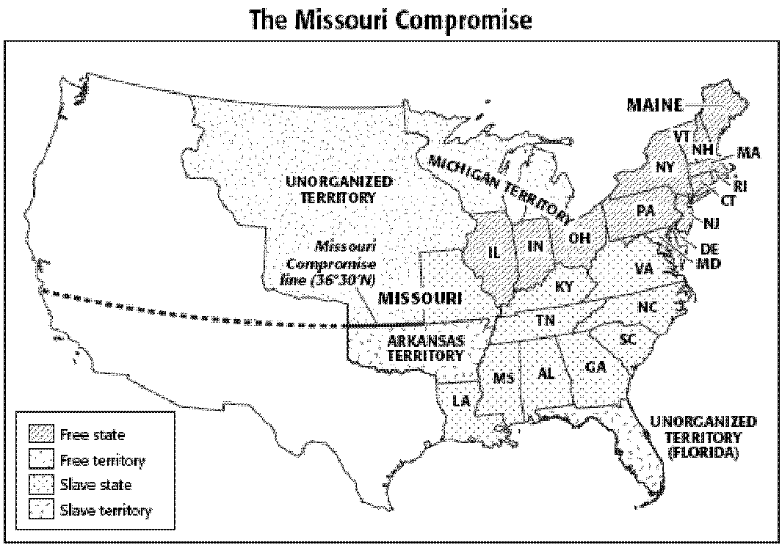

Which part of the United States did not allow slavery in 1820?
What were the consequences of the Missouri Compromise?
During the 1820s, sectionalism grew in the United States. Sectionalism is when politicians do what?
What was Henry Clay’s role in the Missouri Compromise?

How did the Missouri Compromise contribute to the eventual abolition of slavery?

What was significant about the election of 1824?

The winner in the presidential election of 1824 was chosen by whom?

Why did the presidential election of 1824 cause controversy?

What literary style did writer Washington Irving make popular in the United States in the early 19th century?

Why are the works of James Fenimore Cooper so significant to American literary history?

Washington Irving’s “Rip Van Winkle” is an example of which message in his work?

The writings of Washington Irving and James Fenimore Cooper inspired painters in the United States to show what?

The Hudson River school comprised of a group of artists who did what?

Hudson River school paintings reflected feelings of what?

How did the subjects of American paintings of the 1840s differ from those of the 1830s?

Explain Thomas Cole’s contribution to early American art?

What new images were represented in George Caleb Bingham’s paintings in the 1840s?

In the early 1800s, American music focused on what two things?

The popular American folk song “Hunters of Kentucky,” about the Battle of New Orleans, expressed the 1800s’ spirit of what?
What are spirituals?

Why did Americans decide to model much of their architecture after the architecture of ancient Greece and Rome?

In the early 1800s, how were the new American culture’s views on education reflected by education reforms?

Which issue caused disagreement among educators in the 1830s?

