NAME HOUR SCORE

Reconstruction Notes (Reading Assessment)
Chapter 2, Section 4

The Nation Moves Toward Reunion (p. 55-56)
- What was the Freedmen’s Bureau and what were some specific things that it did for African Americans?

- Fill in the T-Chart below with notes on the two different Reconstruction plans (include what was required as a part of each plan for southern states to be readmitted).

Pres. Andrew Johnson’s Plan Radical Republicans’ Plan

- What did the 13th Amendment do?
- In 1868, voted to impeach , but the narrowly voted to NOT remove him from office.

The Reconstruction South (p. 56-58)
- What did the Radical Republicans’ Reconstruction plan require?
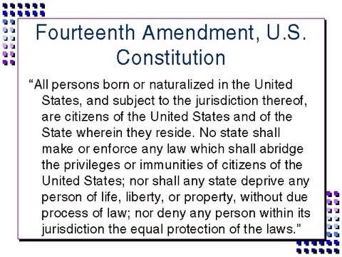

According to the 14th Amendment, who are citizens of the U.S.? Also, identify what can’t be denied to citizens.
- Identify two positive changes that came for African Americans during Reconstruction.

- The Ku Klux Klan used against African Americans and prevented them from .
- The 15th Amendment prohibited voting denial based on .

Reconstruction Comes to an End (p. 58-59)
- Northerners lost interest in Reconstruction as focus shifted to failures, an downturn, and scandals from the administration.

- What arguments did southern white Democrats offer to help them regain power in the South?

- What was the controversy of the 1876 presidential election? What compromise was reached to solve the controversy?

- Fill in the T-Chart below with details or viewpoints that support each argument.

Reconstruction was a Success Reconstruction was a Failure

