Chapter 28 Study Guide

What was a result of prohibition, which was made law in the United States in 1919?

In 1928, Scottish scientist Alexander Fleming discovered what?

How did the League of Nations respond when Japan invaded Manchuria in 1931?

U.S. president Franklin D. Roosevelt proposed a massive package of Depression relief called the what?

What was a key characteristic of fascism in the 1920s and 1930s?

On Stalin’s collectives, who and or what were allowed to do what?

Stalin attempted to make the cultural life of the Soviet Union more Russian by promoting what policy?

France occupied Germany’s coal-rich Ruhr Valley in 1923 because of what?

What 1924 agreement reduced German reparations and provided U.S. loans to Germany?

In 1935, the Nazis passed the Nuremberg Laws which did what?

What could be described as a conservative reaction to the rapid changes in society in the United States after World War I?

Sigmund Freud’s method of studying how the mind words and treating mental disorders is called what?

What was a result of the work of Marie Curie and Albert Einstein?

After most of Ireland became self-governing in 1922, why did the Irish Republican Army (IRA) continue to fight the British?

In Britain during the 1920s, the Labour party supported what?

Describe the economy of the United States in the 1920s?

In the early 1930s, which of the following contributed to the spread of economic problems around the world?

Under Mussolini’s rule in Italy, what transpired in Italy?

What was the appeal of Mussolini’s fascist government to Italians?

What was a cause of Stalin’s Great Purge?

What was a drawback of being among the Soviet elite under Stalin?

What measure did the Nazis take that was a rejection of the Versailles treaty?

Which group sharply criticized the Weimar Republic as too weak and longed for another strong leader like Bismarck?

What were the Eastern European nations that were carved out of old European empires after World War I and what did they have and did not have in comparison to Western European nations?

Eventually, right-wing dictators emerged in every Eastern European country except what country(s)?

Possible Short answer questions

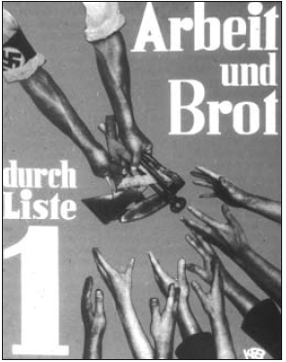

The Nazis used this poster during the 1932 Reichstag election. It reads “Work and Food.” What is the message conveyed in this poster? Why do you think the Nazis viewed this as one of their most effective posters?

Compare and contrast the ways Britain, France, and the United States dealt with the problems created by the Great Depression.

What were the main characteristics of fascist governments of the 1930s? Why did fascists dislike democratic ideals?

The fascists could not have come to power in Italy or Germany without some popular support. Why did many people prefer fascism over a constitutional government?

How did the Soviet Union’s command economy work? Was it successful?

“Without consideration of ‘traditions’ and prejudices, it [Germany] must find the courage to gather our people and their strength for an advance along the road that will lead this people from its present restricted living space to new land and soil, and hence also free it from the danger of vanishing from the earth or of serving others as a slave nation.”

Read the quote above. Describe the course of action that Hitler thinks Germany should follow.

