Chapter 23 Study Guide
Identify, explain, give the significance of the following terms, items, theories, and ideas

 | secret ballot |  | Zionism
 | coalition |  | segregation
 | abolition movement |  | home rule
 | Louisiana Purchase |  | Manifest Destiny
 | capital offense |  | electorate

The British Corn Laws were supported by who?

What did the Catholic Emancipation Act accomplish in Ireland in 1829?

What war brought an end to France’s Second Empire?

What was a result of widespread anti-Semitism in Europe in the late 1800s?

In 1848 in Seneca Falls, New York, Lucretia Mott and Elizabeth Cady Stanton organized what?

Rotten boroughs in Britain were described as?

What happened after the French helped Italian nationalists defeat Austria in the mid-1800s?

Which is true about British social reforms of the mid-1800s?

1In the 1800s, what was a major reason why the Irish resented the British in Ireland?

Name a socialist group that had a strong influence on British politics?

What leader, backed by royalists and ultranationalists, was accused of plotting to overthrow the French republic?

William Lloyd Garrison pushed for what kind of social change?

African Americans were allowed to vote in the United States when what happened?

Which issue in the platform of the Populist Party eventually became law in the United States?

The Traitor, 1899
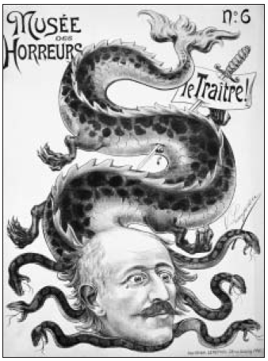

1Draw Inferences The cartoon represents Alfred Dreyfus during his trials for treason in France. Describe the controversy that has inspired the artist to draw the cartoon. What does the cartoon imply about the possibility of Dreyfus getting a fair hearing?

Synthesize Information How were the values represented by Queen Victoria expressed in British social and political reforms of the late 1800s?

Summarize Describe the main reasons for the great economic growth in the United States following the Civil War.

Express Problems Clearly Why did the multiple parties in France find it necessary to form coalition governments during the early years of the Third Republic? What were the disadvantages of this type of government?

Test Conclusions In the early 1900s in Britain, some radical women suffragists turned to violence to achieve their goals. Explain their ideas about protest. Do you agree or disagree with them?

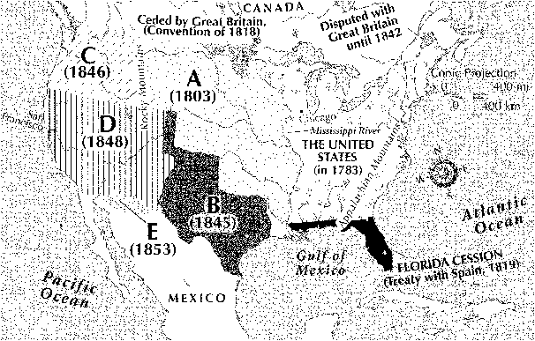

Analyze Information From 1803 to 1853 the United States acquired five large areas of Western land, extending its territories from the Mississippi River to the Pacific Ocean. Identify these areas labeled on the map with the letters A-E. What economic reasons do you think caused the United States to expand its territories to the Pacific Ocean?

