Canada and United States Map Study Guide
*Test on Monday, February 8th for In-Person and Tuesday, February 9th for Virtual students

Be able to identify 10 important physical features of the regions in North America. Their names are listed below
Appalachian Mountains
Arctic Ocean
Atlantic Ocean
Canadian Shield
Colorado River
Great Basin
Great Plains
Mississippi River
Pacific Ocean
Rocky Mountains
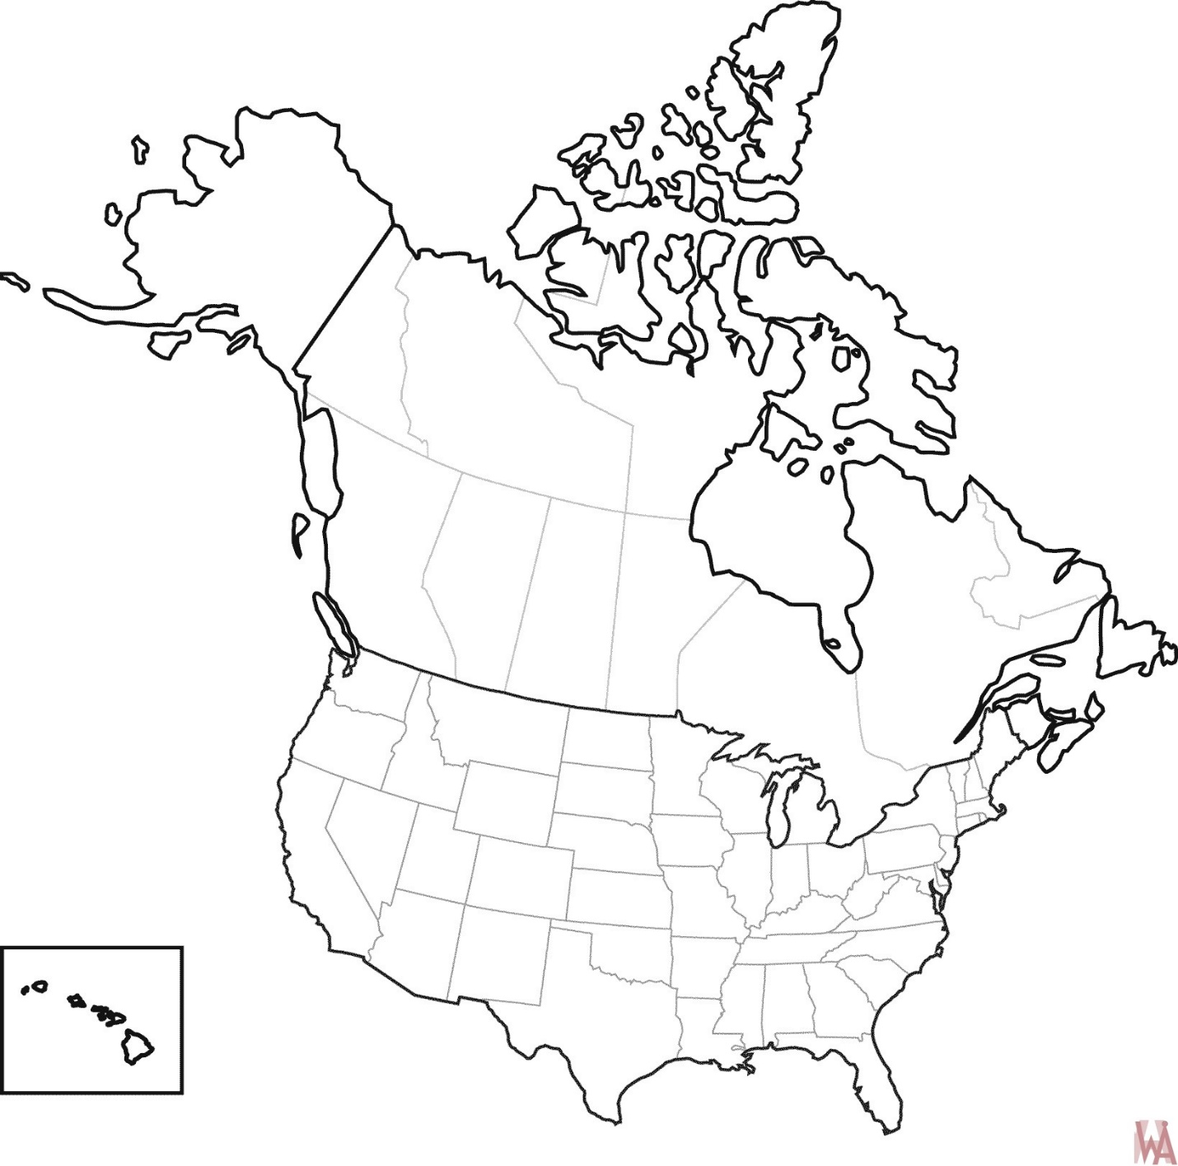
Be able to name and label the 10 important states, provinces, or territories of the region in North America. Their names are listed below.
Alberta
British Columbia
California
Michigan
Montana
New York
Nunavut
Ontario
Oregon
Prince Edward Island

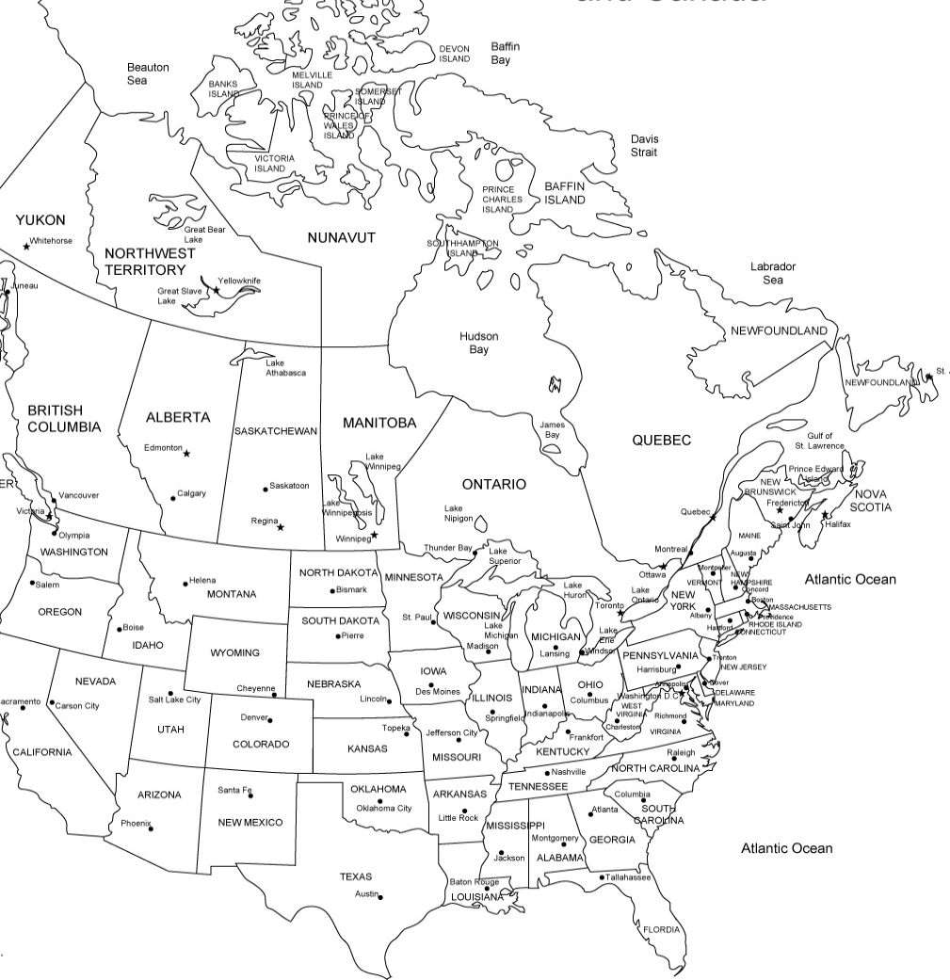

What is the most common type of vegetation in the central area of both southern Canada and the United States?

What is the largest urban center with the highest population in Canada?

Which resource is most abundant in Texas, Alaska, and Alberta?

What climate zone covers most of Canada?

Which states, provinces, or territories is mostly located in a tundra climate zone?

Which states and or provinces has a humid continental climate?

