**Big 3 Warm Up 12/17**

**Word of the Day: Revere**

Definition(s):

1: to be in awe of and respect deeply

2: regard as worthy of great honor

3: have a high opinion of

Example Sentence:

In some cultures people *revere* their ancestors by leaving offerings of food.

Use the word of the day in a sentence and underline the word.

**History/Government Trivia:**

1. In the 1960s, who said this? "Ask not what your country can do for you. Ask what you can do for your country."

a) Abbie Hoffman

b) Dr. Martin Luther King Jr.

c) John F. Kennedy

d) Douglas MacArthur

2. Whose second inaugural address urged healing "with malice toward none, with charity for all"?

a). John Kennedy

b) Woodrow Wilson

c) Abraham Lincoln

d) George Washington

**Picture Response:**

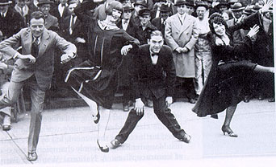

The Charleston is a dance named for the harbor city of Charleston, South Carolina. The rhythm was popularized in mainstream dance music in the United States by a 1923 tune called "The Charleston" by composer/pianist James P. Johnson.

**Write a two to three sentence interpretation of this historic picture and or painting**

**Quote of the Day:** “The best thing about the future is that it comes only one day at a time.”

- **Abraham Lincoln**

**A: C**

**A: C**

**A:**  Richard Nixon

A: Tax evasion. Convicted of income tax evasion in 1931 and sentenced to 11 years in prison, he was released on parole in 1939.