**Big 3 Warm Up 12/02**

**Word of the Day: Serendipity** \ser-uhn-DIP-uh-tee\ , *noun*:

Definition:

**1.**  The faculty or phenomenon of making fortunate accidental discoveries.

Example Sentence:

Yet even as I planned a rough route, leaving plenty of room for **serendipity**, I was uncomfortably aware that journeys have a way of creating their own momentum.

Use the word of the day in a sentence that you have created and underline the word.

**World History/Government Trivia:**

1. In which town or city was General Motors founded?

2. What is the average age at which America's presidents have taken office?

**Picture Response:**

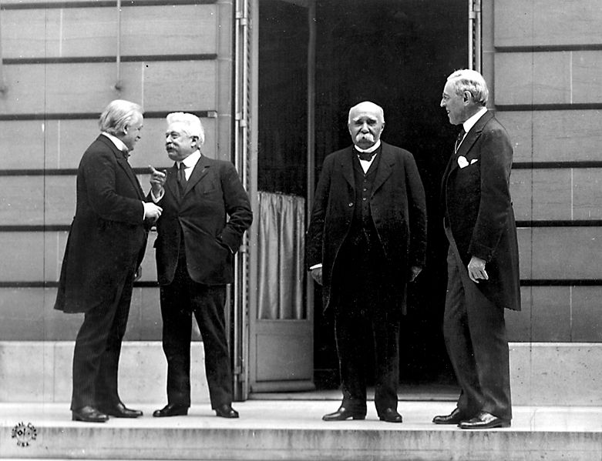

**Write a two to three sentence interpretation of this historic painting**

**Quote of the Day:** “Actions speak louder than words”

**Answer Trivia:**

A: Flint, Michigan

A: 54