**Big 3 Warm Up 03/11/15**

**Word of the Day:** Gazette *noun*

Definition(s):

1**:** newspaper

2**:** an official journal

3**:** an announcement in an official gazette

Example Sentence:

I asked my brother to pick up the monthly car-buyer's gazette when he went into town.

Use the word of the day in a sentence and underline the word.

**World History/Government Trivia:**

1. Which U.S. President was a schoolteacher, soldier, congressman, U.S. senator from Texas?

2. Which U.S. President was a farmer, soldier, haberdasher, judge, and U.S. senator?

**Picture Response:**

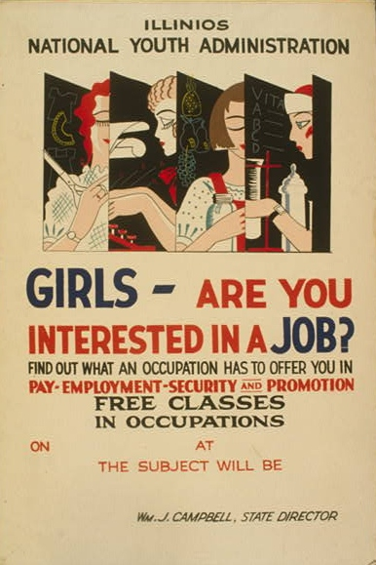

 Poster for the Illinois branch of the National Youth Administration, 1937

**Write a two to three sentence interpretation of this historic picture and or painting**

**Quote of the Day:** “The best thing about the future is that it comes only one day at a time.”

- **Abraham Lincoln**

**A.** Lyndon Baines Johnson

**A.** Harry S. Truman

**A:**  Richard Nixon

A: Tax evasion. Convicted of income tax evasion in 1931 and sentenced to 11 years in prison, he was released on parole in 1939.