**Big 3 Warm Up 03/10/15**

**Word of the Day:** Ratiocination *noun*

Definition(s):

1: the process of exact thinking

2**:** a reasoned train of thought

3**:** reasoning

Example Sentence:

The detective uses a method—whether it is science, some other ratiocination or even intuition—to put things back to normal.

Use the word of the day in a sentence and underline the word.

**World History/Government Trivia:**

1. Who was the candidate in the Presidential Election of 1992, who did not belong to Republican or Democratic Party?

a) Hugh Ross Perot

b) Jack Anderson

c) Patrick Buchanan

d) Walter Mondale

2. Who is the first citizen of USA to be canonized?   
a) Peter Damien  
b) Maximilian Kolbe  
c) Elizabeth Ann Seton  
d) Maria Goretti

3. Which is the tallest building in USA?

a) Empire State

b) Sears Tower

c) White House

d) St. Patrick’s Cathedral

**Picture Response:**

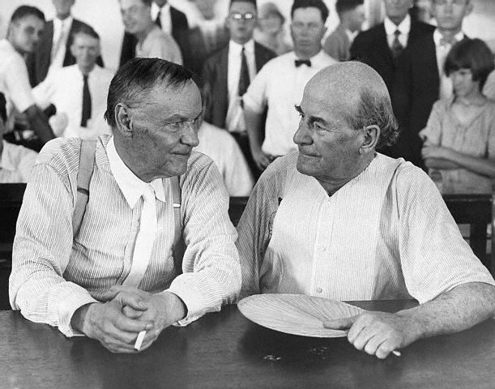

[Clarence Darrow](http://en.wikipedia.org/wiki/Clarence_Darrow) (left) and [William Jennings Bryan](http://en.wikipedia.org/wiki/William_Jennings_Bryan) (right) during the [Scopes Trial](http://en.wikipedia.org/wiki/Scopes_Trial) in [1925](http://en.wikipedia.org/wiki/1925).

**Write a two to three sentence interpretation of this historic picture and or painting**

**Quote of the Day:** “The best thing about the future is that it comes only one day at a time.”

- **Abraham Lincoln**

**A: A**

**A: C**

**A: B**

**A:**  Richard Nixon

A: Tax evasion. Convicted of income tax evasion in 1931 and sentenced to 11 years in prison, he was released on parole in 1939.