Big 3 Warm Up September 21st

Word of the Day:

Facilitation

Definition: act of assisting or making easier the progress or improvement of something

Example: If you volunteer to help with the facilitation of enrolling new students at a school, you might be by the door, handing out forms and directing families to the main office.

In order to receive full credit, you must create your own sentence using the word of the day. You must underline the word of the day in your sentence.

8th Grade Social Studies Trivia:

The Civil War’s direct cost was about how much in 1860 money, which would be $139 billion today. However, some economic historians believe the indirect cost (such as disruption of the economy) would measure approximately $46 trillion in current money.

Picture Response:

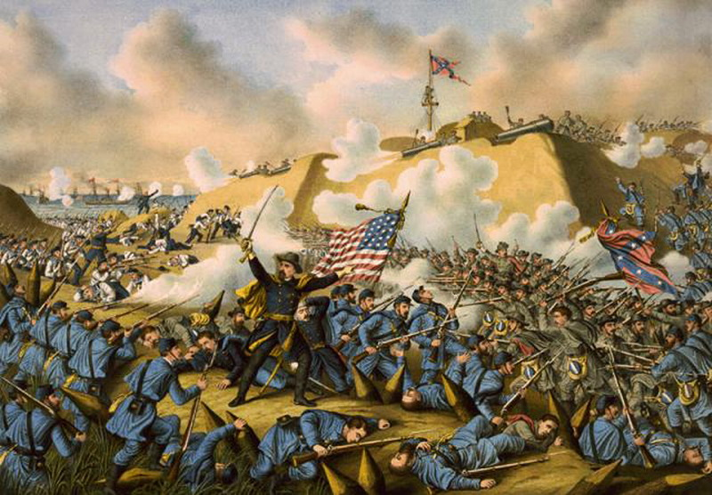

$6.7 billion

