Big 3 Warm Up September 20th

Word of the Day:

Perceptive • adjective
1. Of or relating to perception
2. Having the ability to perceive or understand; keen in discernment

In order to receive full credit, you must create your own sentence using the word of the day. You must underline the word of the day in your sentence.

8th Grade Social Studies Trivia:

This U.S. President was the only man who held both the Presidency and the Vice-Presidency but who was not elected to either post. Who was this U.S. President?

Picture Response:

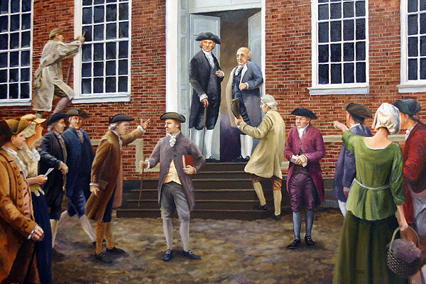

Quote of the Day:
“Actions speak louder than words.”

Gerald Ford

