Big 3 Warm Up September 13th

Word of the Day:

discretion •noun
1. the power of making free choices unconstrained by external agencies
2. freedom to act or judge on one’s own
3. the trait of judging wisely and objectively
4. knowing how to avoid embarrassment or distress
5. refined taste; tact
In order to receive full credit, you must create your own sentence using the word of the day. You must underline the word of the day in your sentence.

American History/Government Trivia:
This President was the first American President to win the Nobel Peace Prize. He won for his arbitration of treaty discussions at the end of the Russo-Japanese War.
Who am I referring to?

Picture Response:

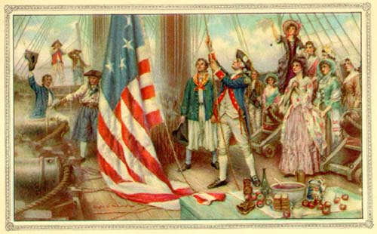

(Example of student response)
Responses will vary

Quote of the School Year:
“Actions speak louder than words.”

Theodore Roosevelt

