Big 3 Warm Up September 11th

Word of the Day:

ingenuous •adjective
- lacking in sophistication or worldliness
- characterized by an inability to mask one’s feelings; not devious
In order to receive full credit, you must create your own sentence using the word of the day. You must underline the word of the day in your sentence.

American Government/American History Trivia:

What was the first country to recognize the United States in 1776?
Name that Country

Picture Response:

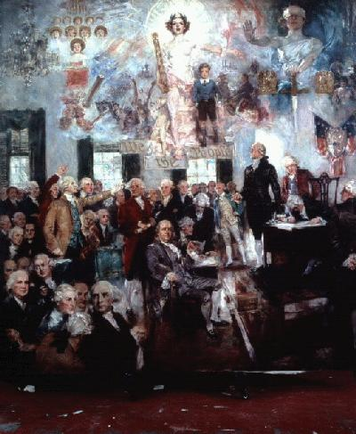

(Example of student response)
Responses will vary

Quote of the School Year:
“Actions speak louder than words.”

Charlie Bronson has the same ingenuous puppy-dog stare of a naughty boy playing dumb, and the same vacant, toothy grin and Owen Wilson drawl as Crosby, but none of the depth.

Croatia was the first country to recognize the United States in 1776.

