Big 3 Warm Up 10/31

Word of the Day: Ghoul

Definitions: is a relatively recent English word, borrowed from Arabic in the 1700s. Because it’s spelled with gh-, it looks vaguely like the Old English words ghost and ghastly (which share a common root in the Old English word _ gāst_, meaning “spirit” or “ghost”). In fact, it comes from the Arabic word ghūl, derived from the verb that means “to seize,” and originally meant “a legendary evil being held to rob graves and feed on corpses.” The word was introduced to western literature by the French translation of Arabian Nights.

Example Sentence: Kids dressed up as Ghoul’s for Halloween.

8th Grade Social Studies Trivia

Where did Jack o’ Lanterns originated from (which country)?

Picture Response

Write two to three sentences based off the image.

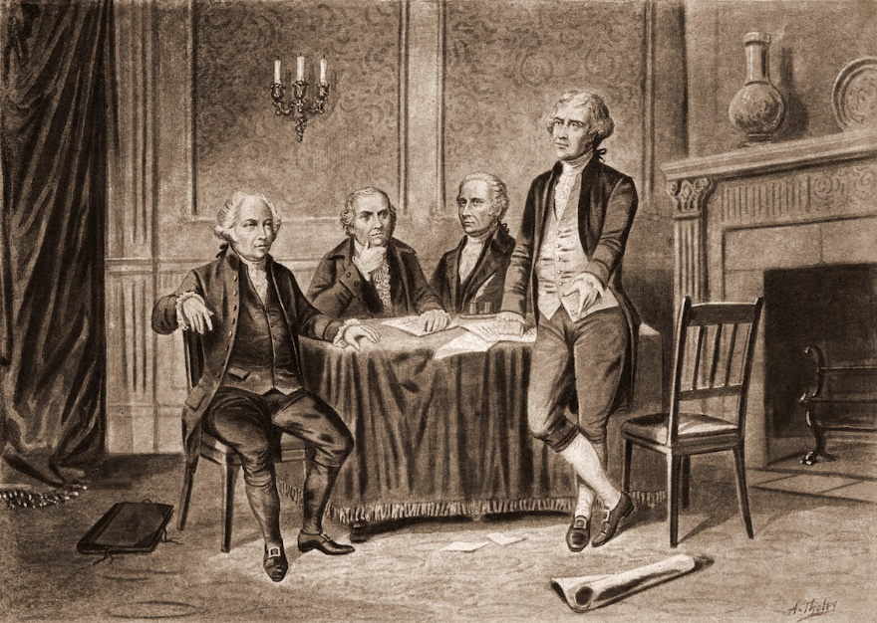

in Ireland where people placed candles in hollowed-out turnips to keep away spirits and ghosts on the Samhain holiday.

Page

